**MINISTRY OF EDUCATION AND TRAINING**



**FPT UNIVERSITY**

Capstone Project Document

**Building Material C2B Website**

|  |  |
| --- | --- |
| **Nhóm số** | |
| **Group members** | Cao Minh Thúy Vy – SE61562 (Team Leader)  Đặng Minh Tùng – SE61703  Trần Anh Nguyên – SE61667  Nguyễn Đình Thiện – SE61446 |
| **Supervisor** | Lại Đức Hùng |
| **Ext. Supervisor** | N/A |
| **Capstone Project code** | Mã đề tài |

-Ho Chi Minh City, ***Ngày bắt đầu làm***-

*This page is intentionally left blank*

**Table of Contents**

Table of Contents ................................................................................................................................3

List of Tables........................................................................................................................................4

Definitions, Acronyms, and Abbreviations..........................................................................................6

A. Report No. 1 Introduction ...........................................................................................................7

1. Project Information .................................................................................................................7

2. Introduction ............................................................................................................................7

3. Current Situation.....................................................................................................................7

4. Problem Definition ..................................................................................................................7

5. Proposed Solution ...................................................................................................................8

5.1 Feature functions ............................................................................................................8

5.2 Advantages and disadvantages .......................................................................................8

6. Functional Requirements ........................................................................................................9

6.1 Name Card Management ................................................. **Error! Bookmark not defined.**

6.2 Event ................................................................................ **Error! Bookmark not defined.**

6.3 Searching .......................................................................... **Error! Bookmark not defined.**

6.4 Suggestion ........................................................................ **Error! Bookmark not defined.**

6.5 User Management ........................................................... **Error! Bookmark not defined.**

7. Role and Responsibility ...........................................................................................................9

**List of Tables**

Table 1: Roles and Responsibilities .....................................................................................................9

**List of Figures**

**Definitions, Acronyms, and Abbreviations**

|  |  |
| --- | --- |
| **Name** | **Definition** |
| BMW | Building Material C2B Website |
| C2B | Customer to Business |
| GUI | Graphic User Interface |

**A. Report No. 1 Introduction**

**1. Project Information**

- Project name: **Building Material C2B Website**

- Project Code: **BMW**

- Product Type: **Web Application**

- Start Date: **03/02/2017**

- End Date:

**2. Introduction**

Nowadays, the demand of building a house is rising. Homeowners are looking forward to find the suitable material supplier. Together with the rapid growth of information technology, especially in e-commerce field. The fact that many e-commerce websites are not really meet the customer’s need. Therefore, we hope to create for our customer a new experience in shopping online based on C2B. In C2B model, sometimes known as Consumer to Business, is a business model where consumers create products and services which are consumed by businesses and organization. According to our research and analysis, we introduce a new solution for building material C2B website.

We build a system which help customers to find more suppliers with the most reasonable price. Suppliers also find their own potential customers. Moreover, building material shops can also improve their revenues by helping customer to find the suitable material.

**3. Current Situation**

Recently, when homeowner is looking forward to building a house, they normally choose traditional way that go directly to the material shop

In VietNam, there aren’t any building material website that based on C2B now. However, around the world, especially in America and India, there are many websites that offer this type of transaction, such as: priceline.com, msupply.com…

**4. Problem Definition**

In VietNam, there aren’t any building material website that based on C2B now. When shopping online, customer must combine with other B2C building material website.

**5. Proposed Solution**

Our solution is to build a new website named “Building Material C2B” to solve the current problem. The website supports the customers find suppliers with the most reasonable price. In addition, our solution is also help supplier find more customers.

BMW includes a web application with following functions:

**5.1 Feature functions**

* **Web application:**
* For customer:
* Posting request for find material, suppliers to build a house.
* Selecting suitable supplier via reverse auction.
* For supplier:
* Bidding: bid to find the suitable orders for their own shop.

**5.2 Advantages and disadvantages**

- Advantages:

* Bring new experience about buy building material.
* Help customer to save time and money.
* Help customer to find their own supplier.
* Help supplier to have more customers, orders.
* Support pre-order/ e-payment via nganluong.vn.

- Disadvantages:

* C2B website is uncommon for customer.
* Supplier sell material at price equal or lower than market price.

**6. Functional Requirements**

* For guest:
  + Register, login.
  + View shop.
* For customer:
* Manage auction: create, cancel, post request.
* Edit profile, send feedback.
* View shops, orders, auctions…
* Search/Filter shops, orders, auctions.
* Chat with supplier.
* Review Request: make a review.
* Logout.
* For supplier:
* Bidding: place a bid, retract…
* Manage shop: create, edit shop, add/edit/delete product.
* Chat with customer.
* View shops, orders, auctions…
* Search/Filter orders, auctions, products, categories, others shops.
* Send feedback.
* For admin:
* Manage all accounts in the system: create, edit, delete.
* Manage all categories, products: create, edit, delete.
* Active/ De-active user.

**7. Role and Responsibility**

|  |  |  |  |  |
| --- | --- | --- | --- | --- |
| **No** | **Full Name** | **Role** | **Position** | **Contact** |
| 1 | Lại Đức Hùng | Project Manager | Supervisor | [hungld@fpt.edu.vn](mailto:hungld@fpt.edu.vn) |
| 2 | Cao Minh Thúy Vy | Developer | Leader | [vycmtse61562@fpt.edu.vn](mailto:vycmtse61562@fpt.edu.vn) |
| 3 | Đặng Minh Tùng | Developer | Member | tungdmse61703[@fpt.edu.vn](mailto:phucnhse60749@fpt.edu.vn) |
| 4 | Trần Anh Nguyên | Developer | Member | [nguyentase61667@fpt.edu.vn](mailto:nguyentase61667@fpt.edu.vn) |
| 5 | Nguyễn Đình Thiện | Developer | Member | [thienndse61446@fpt.edu.vn](mailto:thienndse61446@fpt.edu.vn) |

**Table 1: Roles and Responsibilities**

**B. Report No.2 Software Project Management Plan**

**1. Problem Definition**

* 1. **Name of this Capstone Project**
* Official name: **Building Material C2B Website**
* Vietnamese name: **Website** **C2B mua hàng vật liệu xây dựng**
* Abbreviation: **BMW**

**1.2 Problem Abstract**

We build the system to support customer to buy building material with reasonable price. Our system also support supplier to sell more materials. For that reason we create a C2B website that achieve their requirements. In order to satisfy customer’s demand, we help them create plans. Customer can also make a review about the shops. For supplier, we help them manage their online shop. More than that, we also provide e-payment through Nganluong.vn.

Our system use Google API technology, this technology is quite useful to customers. They can check which shop is the nearest to their location.

**1.3 Project Overview**

**1.3.1 Current Situation**

Below are the problems encountered in this system.

* **Disadvantages:**
* Customer’s habit: customers are used to buy material at material shop when looking forward to building a house.
* System’s security: system allow customer to cancel bid, this function may become a target for cheating.
* E-commerce’s model: C2B model is unfamiliar with customer.
* Require enormous data about construction.

**1.3.2 The Proposed System**

After doing research on technology, we choose Google API because this technology is useful in determine the location. The basic idea is to use Google API to check how far from the supplier’s shop to the customer’s location.

In task assignment, we assign to member using vertical model to make sure if any member in this problem cannot continue to work in our team there will be the least harmful to the project processes.

BMW is built as a web based application. It is high availability (24/7) and fast responds with real-time function.

**1.3.2.1 BMW Web Application**

Our web application includes of three parts:

* For customer:
* Manage auction: create, cancel, post request.
* Edit profile, send feedback.
* View shops, orders, auctions…
* Search/Filter shops, orders, auctions.
* Chat with supplier.
* Review Request: make a review.
* Logout.
* For supplier:
* Bidding: place a bid, retract…
* Manage shop: create, edit shop, add/edit/delete product.
* Chat with customer.
* View shops, orders, auctions…
* Search/Filter orders, auctions, products, categories, others shops.
* Send feedback.
* For admin:
* Manage all accounts in the system: create, edit, delete.
* Manage all categories, products: create, edit, delete.
* Active/De-active user.

**1.3.3 Boundaries of the System**

* Our main target is helping customer to shopping with more convenient and efficient in HaNoi and HoChiMinh city
* Language of system is VietNamese
* The completed product includes:

+ Website application

**1.3.4 Future Plans**

Currently, the system only support in Hanoi and Ho Chi Minh City. In further development, the sytem can:

* Expand location in all province of Vietnam
* Support group buying function.
* Deploy the system in multiple platform (IOS, Android)
* Provide more kind of auction such as: English auction, Dutch auction

**1.3.5 Development Environment**

**1.3.5.1 Hardware requirements**

* For web application server

|  |  |  |
| --- | --- | --- |
| Windows | Minimum Requirements | Recommended |
| Internet Connection | Cable, Wi-Fi (4 Mbps) | Cable, Wi-Fi (8 Mbps) |
| Operating System | Window Server 2008 | Window Server 2008 |
| Computer Processor | Intel® Core i7 2.4 GHz | Intel® Core i7 2.4 GHz |
| Computer Memory | 2GB of RAM | 4GB of RAM or more |

**Table 2: Hardware Requirement for Server**

**1.3.5.2 Software requirements**

|  |  |  |
| --- | --- | --- |
| Software | Name / Version | Description |
| Operating system | Window 10 64 bit | Operating system and platform for development |
| Environment | .NET Framework 4.5 | Specification for developing web application |
| IDE | Visual Studio 2015 | Used for implement website |
| Design Model tool | StartUML v2.5.1 | Used for creating modal and diagrams. |
| DBMS | Microsoft SQL Server 2012 | Used to create & manage the database for system |
| Document system | Github | Used for storing document |
| Store and manage source code | Github & SourceTree | Used to store all source code |

**Table 3: Software Requirement**

**2. Project organization**

**2.1 Software Process Model**

The project is developed under waterfall model. The waterfall model is a [sequential](https://en.wikipedia.org/wiki/Sequence) (non-iterative) [design](https://en.wikipedia.org/wiki/Design) process, used in software development process, in which progress is seen as flowing steadily downwards (like a [waterfall](https://en.wikipedia.org/wiki/Waterfall)) through the phases of conception, initiation, analysis, design, construction, testing, production/implementation and maintenance.

The waterfall model illustrates the software development process in a linear sequential flow; hence it is also referred to as a linear-sequential life cycle model. This means that any phase in the development process begins only if the previous phase is complete.

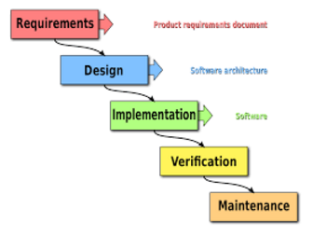

**Figure 1: Modified Waterfall Model**

We use Waterfall Development Model for our project development because:

* We need to have output documents following school’s schedule.
* Business is clear and can be implemented.
* If the requirement change or having trouble when designing, implemenating, testing, you can roll back and change the documents.

Reference: <http://www.waterfall-model.com/sashimi-waterfall-model/>

**2.2 Roles and responsibilities**

|  |  |  |  |
| --- | --- | --- | --- |
| No | Full name | Role in Group | Responsibilities |
| 1 | Lại Đức Hùng | Supervisor, Project Manager | * Specify user requirements * Specify business * Control the development process * Give out technique and business analysis support |
| 2 | Cao Minh Thúy Vy | Team leader, B.A, Developer, Tester | * Managing process * Designing database * Clarifying requirements * Prepare documents * GUI design * Create test plan * Coding * Testing |
| 3 | Đặng Minh Tùng | Team member,  B.A, Developer,  Tester | * Designing database * Clarifying requirements * Prepare documents * GUI design * Create test plan * Coding * Test |
| 4 | Trần Anh Nguyên | Team member,  B.A, Developer,  Tester | * Designing database * Clarifying requirements * Prepare documents * Create test plan * Coding * Test |
| 5 | Nguyễn Đình Thiện | Team member,  B.A, Developer,  Tester | * Designing database * Clarifying requirements * Prepare documents * Create test plan * Coding * Test |

|  |  |
| --- | --- |
| Tool | Name / version |
| Web server | IIS |
| Development tool | Visual Studio 2015 |
| DBMS | SQL Server 2012 |
| Source control | GitHub & SourceTree |
| Modeling tool | StarUML 2.7.1 |
| Document tool | Microsoft Word 2013, Microsoft Excel 2013 |

**Table 4: Roles and Responsibilities Details**

**2.3 Tools and Technique**

**Table 5: Tool List**

|  |  |
| --- | --- |
| Technique | Name / version |
| Frontend | HTML5, CSS3, JavaScript, jQuery, Ajax |
| Backend | ASP.Net MVC 5 |

**Table 6: Technique List**

**3. Project Management Plan**

**3.1 Software development life cycle**

|  |  |  |  |  |  |
| --- | --- | --- | --- | --- | --- |
| Phase | Description | Deliverables | Resouces needed | Dependencies and Constraints | Risks |
| Requirement Analysis | - Collect requirements  - Identify and clarify overall requirements | - Introduction of proposed system  - Software requirement specification  - Project task plan | 20 man – days | N/A | - Unclear project scope, business process  - Lack of sharing understand between members |
| Design | - Create architecture design  - Create detail design by using top-down approach  - Choose architecture style | - Software design documents  - Base code structure | 20 man – days | Requirement Analysis | - Lack of experience  - Not fulfill requirement |
| Implementation | - Code system core functions and other features with GUI  - Create unit test | - Main functions in website | 50 man – days | Design | - Lack of specialized knowledge  - Lack of experience |
| Testing | - Create integration test  - Create alpha test  - Create acceptance test  - Correct bugs | - Test specification | 20 man – days | Implementation | - Lack of experience  - Missing test case |
| Maintenance | - Deploy on web server | - Installation guide  - User mannual | 10 man – days | Testing | - Lack of experience |

**Table 7: Software Development Life Cycle Detail**

**3.2 Phase Detail**

**3.2.1 Phase 1: Requirement Analysis**

|  |  |  |
| --- | --- | --- |
| Task | Description | Author |
| 1. Collect requirements | Define requirement  Find similar website, their strength and weekness | VyCMT, TungDM, NguyenTA, ThienND |
| 1. Identify and clarify main functions | Define main functions that system provide | VyCMT, NguyenTA, ThienND |
| 1. Create system introduction | Complete Introduction Report | VyCMT, TungDM, ThienND |
| 1. Software Management Plan | Prepare Project Management Plan | VyCMT, TungDM, NguyenTA |
| 1. SRS | Create SRS document | VyCMT, ThienND |

**Table 8: Phase 1: Requirement Analysis**

**3.2.2 Phase 2: Design**

|  |  |  |
| --- | --- | --- |
| Task | Description | Author |
| 1. Detail design | Compare new document with existed documents of system | VyCMT, TungDM, NguyenTA, ThienND |
| 1. Database design | Based on parse data to recommendation  Based on other needs to recommendation | TungDM, NguyenTA |
| 1. Technology Research | Study Google API | TungDM, NguyenTA |
| 1. Design document | Create software design document | VyCMT, ThienND |

**Table 9 - Phase 2: Design**

**3.2.3 Phase 3: Implementation**

|  |  |  |
| --- | --- | --- |
| Task | Description | Author |
| 1. Front-end web function | Implement front-end web functions | VyCMT, TungDM, NguyenTA, ThienND |
| 1. Back-end web function | Implement back-end web functions | VyCMT, TungDM, NguyenTA, ThienND |
| 1. Unit testing | Write test case and testing for web functions | VyCMT, TungDM, NguyenTA, ThienND |

**Table 10 - Phase 3: Implementation**

**3.2.4 Phase 4: Test**

|  |  |  |
| --- | --- | --- |
| Task | Description | Author |
| 1. Integration testing | Write test case and testing modules | VyCMT, ThienND |
| 1. Alpha testing | Testing whole system to find bugs that can not be found through other testing | VyCMT, TungDM, NguyenTA, ThienND |

**Table 11 - Phase 4: Test**

* + 1. **Phase 5: Maintenance**

|  |  |  |
| --- | --- | --- |
| Task | Description | Author |
| 1. Installation guide | Write installation guide | VyCMT, TungDM, NguyenTA, ThienND |
| 1. User mannual | Write user mannual | VyCMT, TungDM, NguyenTA, ThienND |

**Table 12 - Phase 5: Maintenance**

**3.3 All Meeting Minutes**

* [https://github.com/Capstone-JS/Documents/Meeting minutes](https://github.com/Capstone-JS/Documents/Meeting%20minutes) (Security: Must be a member of GitHub Repository)

**4. Coding Convention**

* C#: Using to develop website
* Naming Convention:
  + For variable’s name, use Camel Case. Eg: minValue, maxValue…
  + For function name, class name, use Pascal Case. Eg: AddIncome, AddExpense…
* Layout Convention:
  + Indent continuation one tab stop (four spaces).
  + Write only one statement, one declaration per line
  + Add at least one blank line between method definitions and property definitions.
  + Use parentheses to make clauses in an expression apparent.
* Commenting Convention:

+ Place the comment on a separate line, not at the end of a line of code

+ Begin comment text with an uppercase letter

+ End comment text with a period

+ Insert one space between comment delimiter (//) and comment text

References:

**C# Coding Conventions (C# Programming Guide)**

Update: July 20, 2015

<https://msdn.microsoft.com/en-us/library/ff926074.aspx>

**C. Report No. 3 Software Requirement Specification**

**1. User Requirement Specification**

* 1. **Guest Requirement**

Guest is a person who does not have access to the system. Guest can use some functions in the system. To use all functions, guest must login. These are some functions that guest can use:

* Register.
* Login*.*
  1. **User Requirement**

User is a person who uses their account to login to the system. User include customer and supplier. These are some additional functions that user can use:

* Edit profile
* Send feedback
* View shop
* Logout
  1. **Customer Requirement**

Customer is a person who wants to buy material for their house. Customer account must be actived by admin. These are some funtions that customer can use:

* Manage request
* View order
* View request
  1. **Supplier Requirement**

Supplier is a person who wants to sell material to customer. Supplier account must be active by admin. These are some funtions that supplier can use:

* Manage shop
* View Request
* View customer’s order
* Reply request
  1. **Admin Requirement**

Admin is a person who manages whole system. These are some funtions that admin can use

* Manage system’s product
* Manage system’s category
* Manage user
* Manage role
* Manage post

**2. System Requirement Specification**

**2.1 External Interface Requirement**

* + 1. **User Interface**
* General requirement for graphics user interface is the GUI should be simple, clear and intuitive
* The user interface uses Vietnamese language in web application
* The user interface displays best on 1366x768 resolutions on desktop
  + 1. **Hardware Interface**
* Desktop:
  + RAM: 4 GB
  + CPU: 2.5Ghz

**2.1.3 Software Interface**

* Web application: Works with Firefox (v30 or later), Google Chrome (v39 or later), Cốc Cốc (v39 or later) web browser and must supports HTML5, CSS3 and JavaScript.
* The screen must bigger than 1024 x 768 to browse the completely part of document.
  + 1. **Communication Protocol**

- Use HTTP 1.1 to communicate between the web browser and the web server

**2.2 System Overview Use Case**

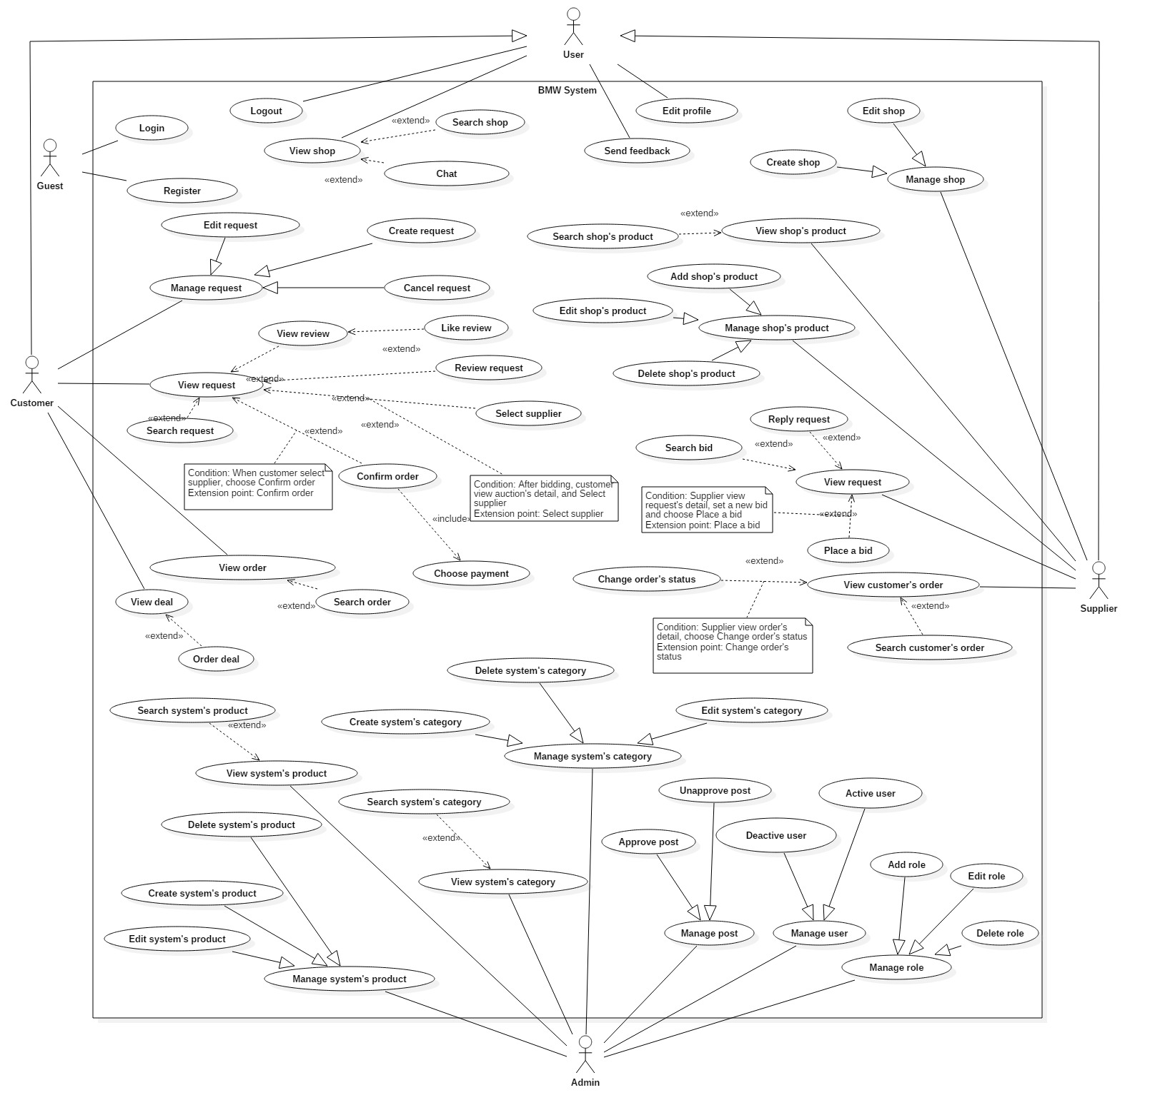

**Figure 2: System Overview Use Case**

**2.3 List of Use Case**

**2.3.1 <Guest>Overview Use Case**

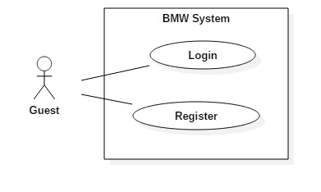

**Figure 3: <Guest> Overview Use Case**

**2.3.1.1 <Guest> Login**

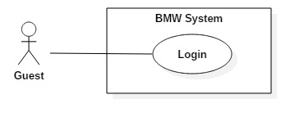

**Figure 4: <Guest>Login**

|  |  |  |  |
| --- | --- | --- | --- |
| **USE CASE – BMW01** | | | |
| **Use Case No.** | BMW01 | **Use Case Version** | 1.0 |
| **Use Case Name** | Login | | |
| **Author** | VyCMT | | |
| **Date** | February 06, 2017 | **Priority** | Normal |
| **Actor:**   * Guest   **Summary:**   * This use case allows guest to login to the system.   **Goal:**   * Guest can login to the system.   **Triggers:**   * In home page, guest click on “Đăng nhập” link.   **Preconditions:**   * Email and password must exist in system.   **Post Conditions:**   * **Success:** Guest is login to the system. * **Fail:** System show error message.   **Main Success Scenario:**   |  |  |  | | --- | --- | --- | | Step | Actor Action | System Response | | 1 | In home page, guest click on “Đăng nhập” link | System show Login page | | 2 | Guest enter information below and click on Login button   * Email * Mật khẩu * Đăng nhập button | System check email valid and verify authorization for account  [Exception 1, 2]  System redirect to role’s view |   **Alternative Scenario: N/A**  **Exception:**   |  |  |  | | --- | --- | --- | | No | Actor action | System Response | | 1 | Guest enter wrong email or password | System shows message “Email hoặt mật khẩu không hợp lệ” | | 2 | Guest do not enter required field | System shows message “Vui lòng điền đầy đủ thông tin bắt buộc” |   **Relationships: N/A**  **Business Rules:**   * When guest click on “Đăng nhập” link, system will authenticate by checking email. * Password field must be encrypted before sending to server. * After logged in to system, guest will be redirected to view based on their role: Customer, Supplier and Admin.   + If the role is “Customer”, the system will display Customer view.  + If the role is “Supplier”, the system will display Supplier view.  + If the role is “Admin”, the system will display Administrator view. | | | |

**Table 2: <Guest>Login**

**2.3.1.1 <Guest> Register**

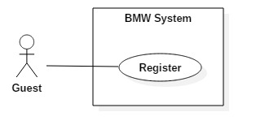

**Figure 5: <Guest> Register**

|  |  |  |  |
| --- | --- | --- | --- |
| **USE CASE – BMW02** | | | |
| **Use Case No.** | BMW02 | **Use Case Version** | 1.0 |
| **Use Case Name** | Register | | |
| **Author** | VyCMT | | |
| **Date** | February 06, 2017 | **Priority** | Normal |
| **Actor:**   * Guest   **Summary:**   * This use case allows guest to register a new account.   **Goal:**   * Guest can register new account according to their roles.   **Triggers:**   * Guest click on “Đăng ký” link.   **Preconditions:** **N/A**  **Post Conditions:**   * **Success:** New account has been added to system * **Fail:** Systemshow error message   **Main Success Scenario:**   |  |  |  | | --- | --- | --- | | Step | Actor Action | System Response | | 1 | In home page, guest click on “Đăng ký” link | System display drop-down list with 2 options:   * Khách hàng * Nhà cung cấp | | 2 | Guest choose between “Khách hàng” and “Nhà cung cấp” | System show Register page | | 3 | Guest enter information below and click on “Đăng ký” button   * Email * Tên đăng nhập * Mật khẩu * Xác nhận mật khẩu * Đăng ký button | System check valid input  [Exception 1, 2, 3, 4]  System send confirmation email | | 4 | Guest check mail and click on Activation link | System confirm and redirect to home page |   **Alternative Scenario: N/A**  **Exception:**   |  |  |  | | --- | --- | --- | | No | Actor action | System Response | | 1 | Guest enter invalid email | System shows message “Email không hợp lệ” | | 2 | Guest enter password that different from confirm password | System shows message “Mật khẩu không phù hợp” | | 3 | Guest do not enter some required fields | System shows message “Vui lòng điền đầy đủ thông tin bắt buộc” | | 4 | Guest register with the same email | System shows message “Email đã tồn tại trong hệ thống” |   **Relationships: N/A**  **Business Rules: N/A** | | | |

**Table 3: <Guest>Register**

**2.3.2 <User>Overview Use Case**

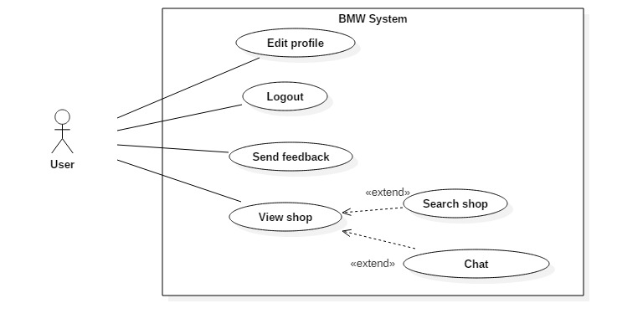



**Figure 6: <User>Overview Use Case**

**2.3.2.1 <User>Logout**

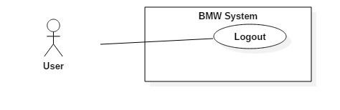

**Figure 7: <User>Logout**

|  |  |  |  |
| --- | --- | --- | --- |
| **USE CASE – BMW03** | | | |
| **Use Case No.** | BMW03 | **Use Case Version** | 1.0 |
| **Use Case Name** | Logout | | |
| **Author** | VyCMT | | |
| **Date** | February 06, 2017 | **Priority** | Normal |
| **Actor:**   * User   **Summary:**   * This use case allows user to log out of the system.   **Goal:**   * User can log out of system.   **Triggers:**   * User click on “Đăng xuất” link   **Preconditions:**   * User logged in the system with role “Khách hàng” or “Nhà cung cấp”   **Post Conditions:**   * **Success:** User can log out of system * **Fail: N/A**   **Main Success Scenario:**   |  |  |  | | --- | --- | --- | | Step | Actor Action | System Response | | 1 | User click on “Đăng xuất” link | Remove current user from system  Redirect to home page |   **Alternative Scenario: N/A**  **Exception: N/A**  **Relationships: N/A**  **Business Rules:**   * After logged out of system, user is no longer has permission to access system’s function. | | | |

**Table 4: <User>Logout**

**2.3.2.2 <User>Edit Profile**

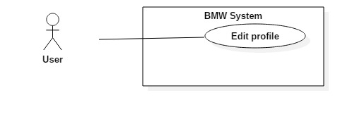

**Figure 8: <User>Edit Profile**

|  |  |  |  |
| --- | --- | --- | --- |
| **USE CASE – BMW0** | | | |
| **Use Case No.** | BMW04 | **Use Case Version** | 1.0 |
| **Use Case Name** | Edit Profile | | |
| **Author** | ThienND | | |
| **Date** | February 10, 2017 | **Priority** | Normal |
| **Actor:**   * User   **Summary:**   * This use case allows User to edit their profile.   **Goal:**   * User can edit their profile.   **Triggers:**   * In “Quản lý tài khoản” page, User click on “Thông tin cá nhân” link.   **Preconditions:**   * User logged in with Customer/Supplier role   **Post Conditions:**   * **Success:** Profile has been updated to system. * **Fail:** System show error message   **Main Success Scenario:**   |  |  |  | | --- | --- | --- | | Step | Actor Action | System Response | | 1 | In “Quản lý tài khoản” page, User click on “Thông tin cá nhân” link | System show “Quản lý tài khoản” page | | 2 | Admin enter information below and click on “Cập nhật” button   * “Tên” * “Ngày sinh” * “Địa chỉ” * “Ảnh đại diện” * “Cập nhật” button | System validate information input.  [Exception 1]  System update profile in system  System show message “Sửa thông tin thành công”  System redirect to “Quản lý tài khoản” page. |   **Alternative Scenario: N/A**  **Exception:**   |  |  |  | | --- | --- | --- | | No | Actor action | System Response | | 1 | User do not enter require fields | System shows message “Vui lòng điền đầy đủ thông tin bắt buộc” |   **Relationships: N/A**  **Business Rules:**   * User can’t update email information. | | | |

**Table 5: <User>Edit Profile**

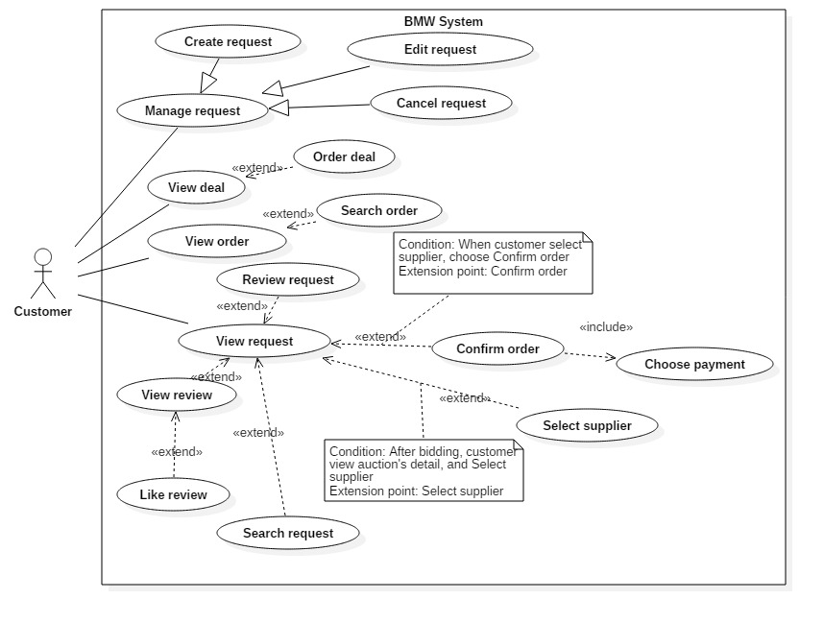**2.3.3 <Customer>Overview Use Case**

**Figure 9: <Customer>Overview Use Case**

**2.3.3.1 <Customer>Create Request**

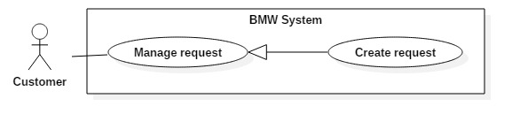

**Figure 10: <Customer>Create Request**

|  |  |  |  |
| --- | --- | --- | --- |
| **USE CASE – BMW0** | | | |
| **Use Case No.** | BMW05 | **Use Case Version** | 1.0 |
| **Use Case Name** | Create Request | | |
| **Author** | VyCMT | | |
| **Date** | February 08, 2017 | **Priority** | Normal |
| **Actor:**   * Customer   **Summary:**   * This use case allows Customer to create request.   **Goal:**   * Customer can create request.   **Triggers:**   * In home page, Customer click on “Đăng yêu cầu” link.   **Preconditions:**   * User logged in with Customer role.   **Post Conditions:**   * **Success:** Request has been added to system. * **Fail:** System show error message   **Main Success Scenario:**   |  |  |  | | --- | --- | --- | | Step | Actor Action | System Response | | 1 | In home page, Customer click on “Đăng yêu cầu” link. | System show Create Request Screen with 2 different areas:   * Yêu cầu mua nhanh * Yêu cầu đấu thầu   [Alternative 1] | | 2 | Customer choose “Yêu cầu mua nhanh” link | System show Request Screen | | 3 | Customer enter information below and click on “Tạo yêu cầu” button   * Danh mục * Tiêu đề * Nội dung * Giá * Số lượng * Thời hạn kết thúc * Phương thức thanh toán * Địa chỉ giao hàng * Tạo yêu cầu button | System validate information input  [Exception 1]  System inserts request into system  System redirect to View Request Screen |   **Alternative Scenario:**  [Alternative 1]   |  |  |  | | --- | --- | --- | | Step | Actor action | System Response | | 1 | Customer choose “Yêu cầu đấu thầu” link | System show Request page | | 2 | Customer enter information below and click on “Tạo yêu cầu” button   * Danh mục * Tiêu đề * Thành phố * Nội dung * Giá khởi điểm * Hình ảnh * Tạo yêu cầu button | System validate information input  [Exception 2]  System inserts request into system  System redirect to View Request Screen |   **Exception:**   |  |  |  | | --- | --- | --- | | No | Actor action | System Response | | 1 | Customer do not enter require fields in Normal Request Screen | System shows message “Vui lòng điền đầy đủ thông tin bắt buộc” | | 2 | Customer do not enter require fields in Bid Request Screen | System shows message “Vui lòng điền đầy đủ thông tin bắt buộc” |   **Relationships: N/A**  **Business Rules:**   * By default, system will set time for any bidding is 5 minutes. | | | |

**Table 6: <Customer>Create Request**

**2.3.3.2 <Customer>Edit Request**

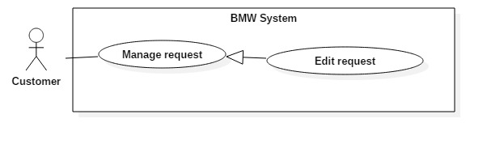

**Figure 11: <Customer>Edit Request**

|  |  |  |  |
| --- | --- | --- | --- |
| **USE CASE – BMW0** | | | |
| **Use Case No.** | BMW06 | **Use Case Version** | 1.0 |
| **Use Case Name** | Edit Request | | |
| **Author** | VyCMT | | |
| **Date** | February 10, 2017 | **Priority** | Normal |
| **Actor:**   * Customer   **Summary:**   * This use case allows Customer to edit request.   **Goal:**   * Customer can edit request   **Triggers:**   * In “View Request” page , Customer choose request and click on “Chỉnh sửa” button   **Preconditions:**   * User logged in with Customer role * Request has been created in system.   **Post Conditions:**   * **Success:** Request has been updated to system. * **Fail:** System show error message   **Main Success Scenario:**   |  |  |  | | --- | --- | --- | | Step | Actor Action | System Response | | 1 | In “View Request” page , Customer choose request and click on “Chỉnh sửa” button | System show list of Request include:   * Danh mục * Tiêu đề * Nội dung * Giá * Chỉnh sửa button | | 3 | Customer enter information and click on “Chỉnh sửa” button | System validate information input  [Exception 1]  System display message “Bạn đã chỉnh sửa thành công”  System redirect to “View Request” page |   **Alternative Scenario: N/A**  **Exception:**   |  |  |  | | --- | --- | --- | | No | Actor action | System Response | | 1 | Customer do not choose request and click on “Chỉnh sửa yêu cầu” button | System show error message “Bạn phải chọn yêu cầu bất kỳ” |   **Relationships: N/A**  **Business Rules:**   * In case of Bid Request, Customer can edit request when status is “Chưa duyệt” | | | |

**Table 7: <Customer>Edit Request**

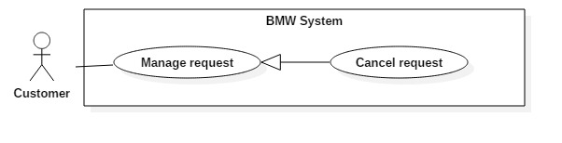**2.3.3.3 <Customer>Cancel Request**

**Figure 12: <Customer>Cancel Request**

|  |  |  |  |
| --- | --- | --- | --- |
| **USE CASE – BMW0** | | | |
| **Use Case No.** | BMW07 | **Use Case Version** | 1.0 |
| **Use Case Name** | Cancel Request | | |
| **Author** | VyCMT | | |
| **Date** | February 07, 2017 | **Priority** | Normal |
| **Actor:**   * Customer   **Summary:**   * This use case allows Customer to cancel request.   **Goal:**   * Customer can cancel request   **Triggers:**   * In “View Request” page , Customer choose request and click on “Xóa” button   **Preconditions:**   * User logged in with Customer role * Request has been created in system.   **Post Conditions:**   * **Success:** Request has been deleted from system. * **Fail:** System show error message   **Main Success Scenario:**   |  |  |  | | --- | --- | --- | | Step | Actor Action | System Response | | 1 | In “View Request” page , Customer choose request and click on “Xóa” button  [Exception 1] | System show Cancel Request form with Dialog “Bạn có đồng ý hủy yêu cầu này hay không?   * Đồng ý button * Hủy button   [Alternative 1] | | 3 | Customer click on “Đồng ý” button | System deletes request from system  System show message “Bạn đã xóa thành công”  System redirect to “Quản lý yêu cầu” page |   **Alternative Scenario:**  [Alternative 1]   |  |  |  | | --- | --- | --- | | Step | Actor action | System Response | | 1 | Customer click on “Hủy” button | Dialog disappear and nothing change |   **Exception:**   |  |  |  | | --- | --- | --- | | No | Actor action | System Response | | 1 | Customer do not choose request and click on “Hủy yêu cầu” button | System show error message “Bạn phải chọn yêu cầu bất kỳ” |   **Relationships: N/A**  **Business Rules:**   * In case of Bid Request, Customer can delete request when status is “Chưa duyệt” | | | |

**Table 8: <Customer>Cancle Request**

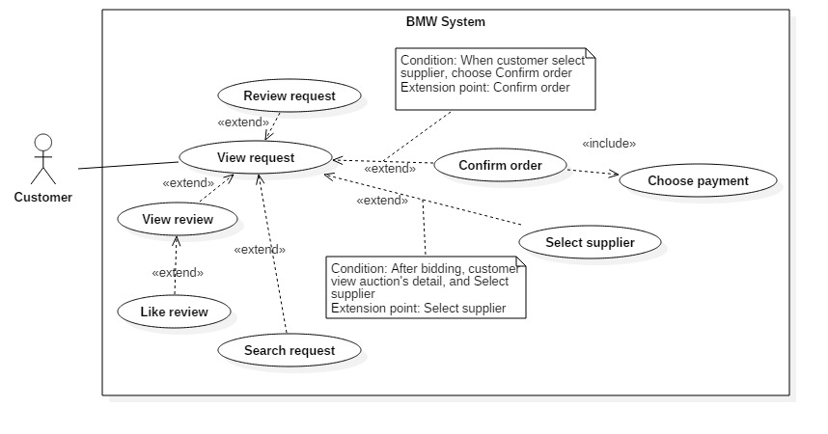**2.3.3.4 <Customer>View Request**

**Figure 13: <Customer>View Request**

|  |  |  |  |
| --- | --- | --- | --- |
| **USE CASE – BMW0** | | | |
| **Use Case No.** | BMW08 | **Use Case Version** | 1.0 |
| **Use Case Name** | View Request | | |
| **Author** | VyCMT | | |
| **Date** | February 09, 2017 | **Priority** | Normal |
| **Actor:**   * Customer   **Summary:**   * This use case allows Customer to view their request.   **Goal:**   * Customer can view request details   **Triggers:**   * In “Quản lý yêu cầu” page, Customer choose and click on request.   **Preconditions:**   * User logged in with Customer role * Request has been created in system.   **Post Conditions:**   * **Success:** Customer can view their request * **Fail: N/A**   **Main Success Scenario:**   |  |  |  | | --- | --- | --- | | Step | Actor Action | System Response | | 1 | In “Quản lý yêu cầu” page, Customer choose and click on request. | System display View Detail page with information below   * Thời gian còn lại * Bảng xếp hạng đấu thầu |   **Alternative Scenario: N/A**  **Exception: N/A**  **Relationships: N/A**  **Business Rules: N/A** | | | |

**Table 9: <Customer>View Request**

**2.3.3.5 <Customer>Review Request**

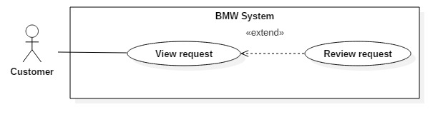**Figure 14: <Customer>Review Request**

|  |  |  |  |
| --- | --- | --- | --- |
| **USE CASE – BMW0** | | | |
| **Use Case No.** | BMW09 | **Use Case Version** | 1.0 |
| **Use Case Name** | Review Request | | |
| **Author** | VyCMT | | |
| **Date** | February 11, 2017 | **Priority** | Normal |
| **Actor:**   * Customer   **Summary:**   * This use case allows Customer to Review Request.   **Goal:**   * Customer can Review Request.   **Triggers:**   * In “Quản lý yêu cầu” page, Customer choose and click on request.   **Preconditions:**   * User logged in with Customer role * Order has been created in system.   **Post Conditions:**   * **Success:** Customer can Review Request * **Fail: N/A**   **Main Success Scenario:**   |  |  |  | | --- | --- | --- | | Step | Actor Action | System Response | | 1 | In “Quản lý yêu cầu” page, Customer choose and click on request | System show Review Request form | | 2 | Customer enter information below and click on “Gửi đánh giá” button   * Nhận xét chung * Tiêu đề * Mô tả đánh giá * Gửi đánh giá button | System insert review to system |   **Alternative Scenario: N/A**  **Exception: N/A**  **Relationships: N/A**  **Business Rules:**   * Customer can Review Request after order is delivered | | | |

**Table 10: <Customer>Review Request**

**2.3.4 <Supplier>Overview Use Case**

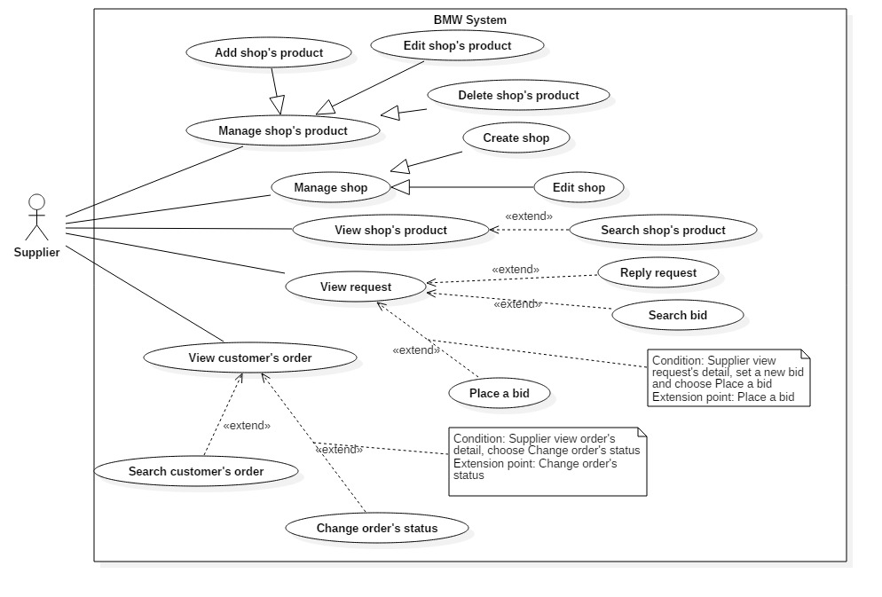

**Figure 15: <Supplier>Overview Use Case**

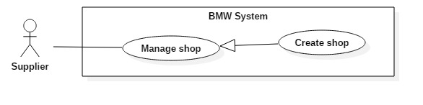**2.3.4.1 <Supplier>Create Shop**

**Figure 16: <Supplier>Create Shop**

|  |  |  |  |
| --- | --- | --- | --- |
| **USE CASE – BMW0** | | | |
| **Use Case No.** | BMW10 | **Use Case Version** | 1.0 |
| **Use Case Name** | Create Shop | | |
| **Author** | ThienND | | |
| **Date** | February 08, 2017 | **Priority** | Normal |
| **Actor:**   * Supplier   **Summary:**   * This use case allows Supplier to create shop.   **Goal:**   * Supplier can create their own shop.   **Triggers:**   * Supplier click on “Tạo cửa hàng” button.   **Preconditions:**   * User logged in with Supplier role   **Post Conditions:**   * **Success:** New shop has been added to system. * **Fail:** System show error message   **Main Success Scenario:**   |  |  |  | | --- | --- | --- | | Step | Actor Action | System Response | | 1 | Supplier goes to “Quản lý cửa hàng” page and click on “Tạo cửa hàng” button | System show “Tạo cửa hàng” Screen | | 2 | Supplier enter information below and click on “Tạo cửa hàng” button   * “Tên cửa hàng” * “Địa chỉ” * “Thành phố” * “Quận/Huyện” * “Tạo cửa hàng” button | System validate information input  [Exception 1]  System inserts shop into system  System redirect to “Quản lý cửa hàng” page. |   **Alternative Scenario: N/A**  **Exception:**   |  |  |  | | --- | --- | --- | | No | Actor action | System Response | | 1 | Supplier do not enter some require fields | System shows message “Vui lòng điền đầy đủ thông tin bắt buộc” |   **Relationships: N/A**  **Business Rules: N/A** | | | |

**Table 11: <Supplier>Create Shop**

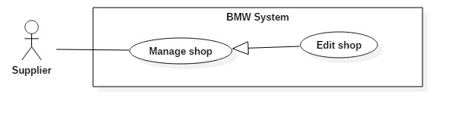**2.3.4.2 <Supplier>Edit Shop**

**Figure 17: <Supplier>Edit Shop**

|  |  |  |  |
| --- | --- | --- | --- |
| **USE CASE – BMW0** | | | |
| **Use Case No.** | BMW11 | **Use Case Version** | 1.0 |
| **Use Case Name** | Edit Shop | | |
| **Author** | ThienND | | |
| **Date** | February 08, 2017 | **Priority** | Normal |
| **Actor:**   * Supplier   **Summary:**   * This use case allows Supplier to edit shop.   **Goal:**   * Supplier edits shop information into system.   **Triggers:**   * Supplier click the “Chỉnh sửa cửa hàng” button.   **Preconditions:**   * User logged in Supplier role   **Post Conditions:**   * **Success:** Information has been updated to system. * **Fail:** System show error message   **Main Success Scenario:**   |  |  |  | | --- | --- | --- | | Step | Actor Action | System Response | | 1 | Supplier goes to “Quản lý cửa hàng” Page and click on “Chỉnh sửa” button | System show Edit Shop form. | | 2 | Supplier enter the information below and click on “Chỉnh sửa” button   * “Tên cửa hàng” * “Địa chỉ” * “Thành phố” * “Quận/Huyện” * “Chỉnh sửa” button | System validate information input  [Exception 1]  System updated product into system  System redirect to “Quản lý cửa hàng” page. |   **Alternative Scenario: N/A**  **Exception:**   |  |  |  | | --- | --- | --- | | No | Actor action | System Response | | 1 | Supplier do not enter some require fields | System shows message “Vui lòng điền đầy đủ thông tin bắt buộc” |   **Relationships: N/A**  **Business Rules: N/A** | | | |

**Table 12: <Supplier>Edit Shop**

**2.3.4.3 <Supplier>Add Shop’s Product**

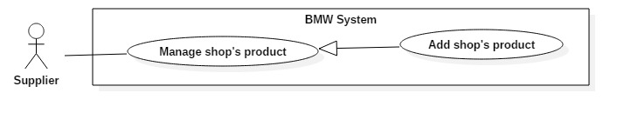

**Figure 18: <Supplier>Add Shop’s Product**

|  |  |  |  |
| --- | --- | --- | --- |
| **USE CASE – BMW0** | | | |
| **Use Case No.** | BMW12 | **Use Case Version** | 1.0 |
| **Use Case Name** | Add Shop’s Product | | |
| **Author** | VyCMT | | |
| **Date** | February 11, 2017 | **Priority** | Normal |
| **Actor:**   * Supplier   **Summary:**   * This use case allows Supplier to add product to shop.   **Goal:**   * Supplier can add product to their shop.   **Triggers:**   * In home page, Supplier click on the “Đăng sản phẩm” link.   **Preconditions:**   * User logged in Supplier role * Shop must be existed in system   **Post Conditions:**   * **Success:** New products has been added to shop. * **Fail:** System show error message   **Main Success Scenario:**   |  |  |  | | --- | --- | --- | | Step | Actor Action | System Response | | 1 | In home page, Supplier click on the “Đăng sản phẩm” link | System show Add Product form. | | 2 | Supplier enter the information below and click on “Tạo mới” button   * Tên sản phẩm * Số lượng * Giá * Hình ảnh * Mô tả * “Tạo mới” button | System validate information input  [Exception 1]  System add product into shop.  System redirect to “View Shop” page. |   **Alternative Scenario: N/A**  **Exception:**   |  |  |  | | --- | --- | --- | | No | Actor action | System Response | | 1 | Supplier do not enter require fields | System shows message “Vui lòng điền đầy đủ thông tin bắt buộc” |   **Relationships: N/A**  **Business Rules: N/A** | | | |

**Table 13: <Supplier>Add Shop’s Product**

**2.3.4.3 <Supplier>Edit Shop’s Product** 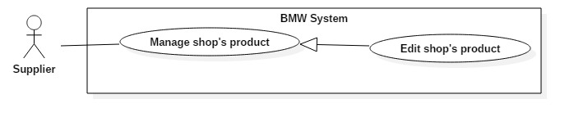

**Figure 19: <Supplier>Edit Shop’s Product**

|  |  |  |  |
| --- | --- | --- | --- |
| **USE CASE – BMW0** | | | |
| **Use Case No.** | BMW13 | **Use Case Version** | 1.0 |
| **Use Case Name** | Edit Shop’s Product | | |
| **Author** | VyCMT | | |
| **Date** | February 11, 2017 | **Priority** | Normal |
| **Actor:**   * Supplier   **Summary:**   * This use case allows Supplier to edit shop’s product.   **Goal:**   * Supplier can edit shop’s product.   **Triggers:**   * In “Quản lý cửa hàng” page, Supplier choose product and click on the “Chỉnh sửa” button.   **Preconditions:**   * User logged in Supplier role * Product is existed in shop   **Post Conditions:**   * **Success:** Product has been updated to shop. * **Fail:** System show error message   **Main Success Scenario:**   |  |  |  | | --- | --- | --- | | Step | Actor Action | System Response | | 1 | In “Quản lý cửa hàng” page, Supplier choose product and click on the “Chỉnh sửa” button | System show Edit Product form. | | 2 | Supplier enter the information below and click on “Chỉnh sửa” button   * Tên sản phẩm * Số lượng * Giá * Hình ảnh * Mô tả * “Chỉnh sửa” button | System validate information input  [Exception 1]  System updated product into shop  System redirect to “Quản lý cửa hàng” page. |   **Alternative Scenario: N/A**  **Exception:**   |  |  |  | | --- | --- | --- | | No | Actor action | System Response | | 1 | Supplier do not enter require fields | System shows message “Vui lòng điền đầy đủ thông tin bắt buộc” |   **Relationships: N/A**  **Business Rules: N/A** | | | |

**Table 14: <Supplier>Edit Shop’s Product**

**2.3.4.3 <Supplier>Delete Shop’s Product**

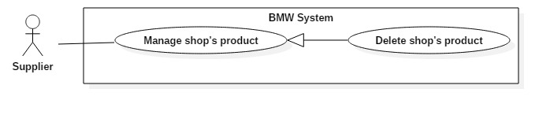

**Figure 20: <Supplier>Delete Shop’s Product**

|  |  |  |  |
| --- | --- | --- | --- |
| **USE CASE – BMW0** | | | |
| **Use Case No.** | BMW14 | **Use Case Version** | 1.0 |
| **Use Case Name** | Delete Shop’s Product | | |
| **Author** | VyCMT | | |
| **Date** | February 11, 2017 | **Priority** | Normal |
| **Actor:**   * Supplier   **Summary:**   * This use case allows Supplier to delete shop.   **Goal:**   * Supplier can delete product from shop.   **Triggers:**   * In “Quản lý cửa hàng” page, Supplier choose product and click on the “Xóa” button.   **Preconditions:**   * User logged in Supplier role * Product is existed in shop   **Post Conditions:**   * **Success:** Product has been deleted from shop. * **Fail:** System show error message   **Main Success Scenario:**   |  |  |  | | --- | --- | --- | | Step | Actor Action | System Response | | 1 | In “Quản lý cửa hàng” page, Supplier choose product and click on the “Xóa” button | System show Delete Shop form.   * Đồng ý button * Hủy button | | 2 | Supplier choose “Đồng ý” button | System remove product from shop  System show message “Bạn đã xóa thành công”  System redirect to “Quản lý cửa hàng” page. |   **Alternative Scenario:**  [Alternative 1]   |  |  |  | | --- | --- | --- | | Step | Actor action | System Response | | 1 | Supplier choose “Hủy” button | Dialog disapper and nothing change |   **Exception: N/A**  **Relationships: N/A**  **Business Rules: N/A** | | | |

**Table 15: <Supplier>Delete Shop’s Product**

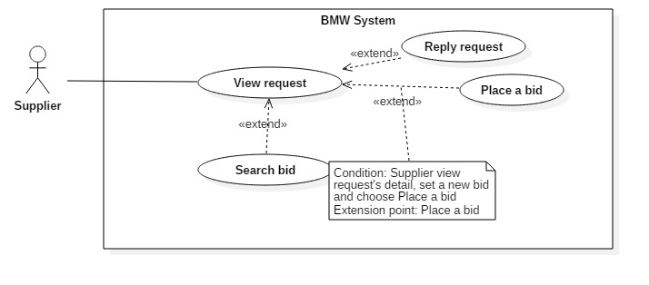**2.3.4.3 <Supplier>View Request**

**Figure 21: <Supplier>View Request**

|  |  |  |  |
| --- | --- | --- | --- |
| **USE CASE – BMW0** | | | |
| **Use Case No.** | BMW15 | **Use Case Version** | 1.0 |
| **Use Case Name** | View Request | | |
| **Author** | VyCMT | | |
| **Date** | February 10, 2017 | **Priority** | Normal |
| **Actor:**   * Supplier   **Summary:**   * This use case allows Supplier to View Request.   **Goal:**   * Supplier can view their bid.   **Triggers:**   * Supplier click on “Quản lý yêu cầu” link   **Preconditions:**   * User logged in with Supplier role   **Post Conditions:**   * **Success:** Supplier View Request. * **Fail:** System show error message   **Main Success Scenario:**   |  |  |  | | --- | --- | --- | | Step | Actor Action | System Response | | 1 | Supplier click on “Quản lý yêu cầu” link | System show View Request form with information belown:   * Thời gian còn lại * Thứ hạng hiện tại * Giá thầu hiện tại |   **Alternative Scenario: N/A**  **Exception: N/A**  **Relationships:**   * Extend “Place a bid” * Extend “Retract a bid” * Extend “Reply request”   **Business Rules: N/A** | | | |

**Table 16: <Supplier> View Request**

**2.3.4.6 <Supplier>Place A Bid**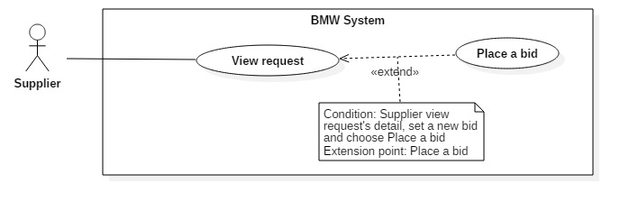

**Figure 22: <Supplier>Place A Bid**

|  |  |  |  |
| --- | --- | --- | --- |
| **USE CASE – BMW0** | | | |
| **Use Case No.** | BMW16 | **Use Case Version** | 1.0 |
| **Use Case Name** | Place A Bid | | |
| **Author** | VyCMT | | |
| **Date** | February 10, 2017 | **Priority** | Normal |
| **Actor:**   * Supplier   **Summary:**   * This use case allows Supplier to place a bid.   **Goal:**   * Supplier can place a bid many times.   **Triggers:**   * In View Request page, Supplier click on “Đặt giá” button   **Preconditions:**   * User logged in with Supplier role   **Post Conditions:**   * **Success:** Supplier place a bid * **Fail:** System show error message   **Main Success Scenario:**   |  |  |  | | --- | --- | --- | | Step | Actor Action | System Response | | 1 | In View Request page, Supplier click on “Đặt giá” button | System show View Request form | | 2 | Supplier enter information belown and click on “Xác nhận” button   * Giá giảm tối thiểu * Giá thầu * Xác nhận button | System validate information input  [Exception 1, 2, 3]  System redirect to … page |   **Alternative Scenario: N/A**  **Exception:**   |  |  |  | | --- | --- | --- | | No | Actor action | System Response | | 1 | Supplier do not enter required field | System shows error message “Vui lòng nhập đầy đủ thông tin bắt buộc” | | 2 | Supplier enter text data | System show error message “Vui lòng nhập số” | | 3 | Supplier enter number less than 0 | System show error message “Vui lòng nhập số lớn hơn 0” |   **Relationships: N/A**  **Business Rules:**   * The first online bid can be equal to or less than start price. * The second online bid must be lower than the first bid. * The minimum bid decrement value is available at the start of bidding process. | | | |

**Table 17: <Supplier> Place A Bid**

**2.3.5 <Admin>Overview Use Case**

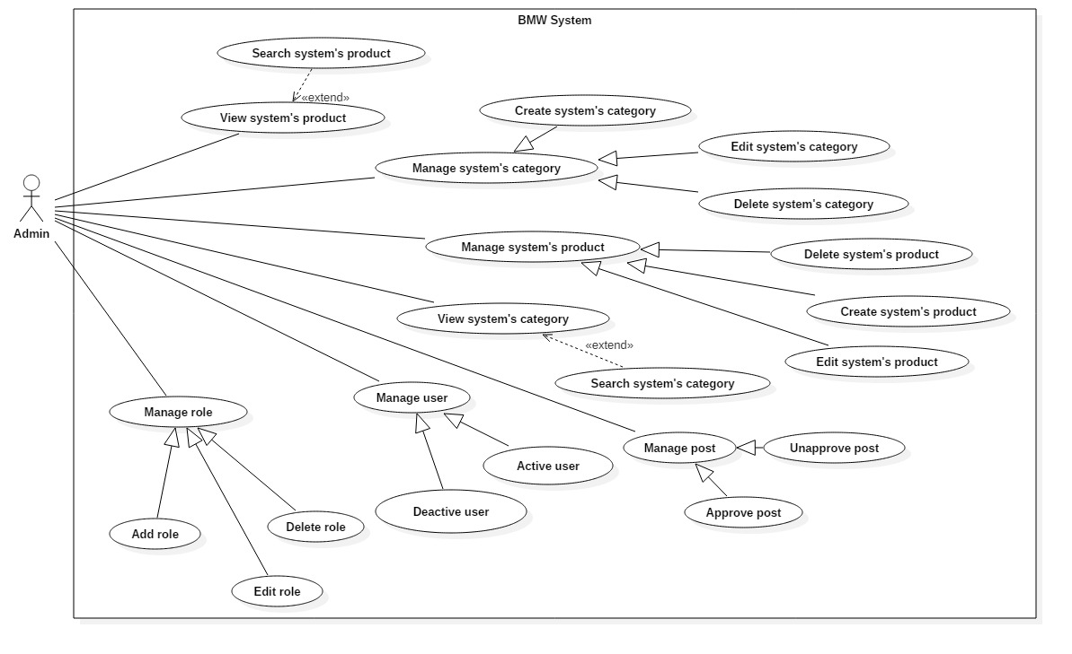**Figure 23: <Admin>Overview Use Case**

**2.3.5.1 <Admin>Create System’s Product**

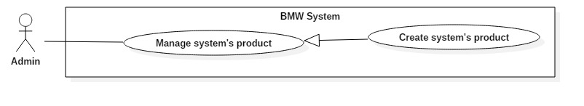**Figure 24: <Admin>Create System’s Product**

|  |  |  |  |
| --- | --- | --- | --- |
| **USE CASE – BMW0** | | | |
| **Use Case No.** | BMW17 | **Use Case Version** | 1.0 |
| **Use Case Name** | Create System’s Product | | |
| **Author** | ThienND | | |
| **Date** | February 10, 2017 | **Priority** | Normal |
| **Actor:**   * Admin   **Summary:**   * This use case allows Admin to create new product.   **Goal:**   * Admin can create new product.   **Triggers:**   * Admin goes to “Quản lý sản phẩm” Page and click on “Tạo sản phẩm” button.   **Preconditions:**   * User logged in with Admin role   **Post Conditions:**   * **Success:** New product has been added to system. * **Fail:** System show error message   **Main Success Scenario:**   |  |  |  | | --- | --- | --- | | Step | Actor Action | System Response | | 1 | Admin goes to “Quản lý sản phẩm” Page and click on “Tạo sản phẩm” button | System show “Quản lý sản phẩm” Page | | 2 | Admin enter information below and click on “Tạo mới” button   * “Tên” * “Nhà sản xuất” * “Danh mục” * “Giá” * “Hình ảnh” * “Tạo mới” button | System validate information input  [Exception 1]  System insert product into system  System show “Sản phẩm đã được tạo thành công”  System redirect to “Quản lý sản phẩm” Page |   **Alternative Scenario: N/A**  **Exception:**   |  |  |  | | --- | --- | --- | | No | Actor action | System Response | | 1 | Admin do not enter require fields | System shows message “Vui lòng điền đầy đủ thông tin bắt buộc” |   **Relationships: N/A**  **Business Rules:**   * Product must belong to one category * Product must belong to one manufacturer * Image type: should be JPG or PNG | | | |

**Table 18: <Admin> Create System’s Product**

**2.3.5.2 <Admin>View System’s Product**

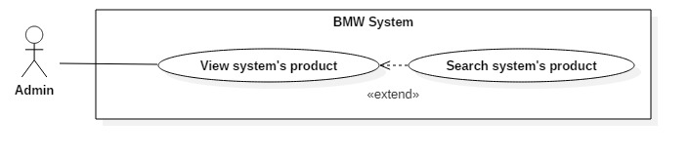

**Figure 25: <Admin>View System’s Product**

|  |  |  |  |
| --- | --- | --- | --- |
| **USE CASE – BMW0** | | | |
| **Use Case No.** | BMW18 | **Use Case Version** | 1.0 |
| **Use Case Name** | View System’s Product | | |
| **Author** | ThienND | | |
| **Date** | February 10, 2017 | **Priority** | Normal |
| **Actor:**   * Admin   **Summary:**   * This use case allows Admin to view list of products.   **Goal:**   * Admin can view list of products.   **Triggers:**   * Admin goes to “Quản lý sản phẩm” Page.   **Preconditions:**   * User logged in with Admin role   **Post Conditions:**   * **Success:** System show all products. * **Fail:** System show error message   **Main Success Scenario:**   |  |  |  | | --- | --- | --- | | Step | Actor Action | System Response | | 1 | Admin goes to “Quản lý sản phẩm” Page | System get and show product list. Each product include:   * “Tên” * “Nhà sản xuất” * “Danh mục” * “Giá” * “Hình ảnh” |   **Alternative Scenario: N/A**  **Exception: N/A**  **Relationships:**   * Extend “Edit System’s Product” * Extend “Delete System’s Product” * Extend “Search System’s Product”   **Business Rules:**   * Product list will be sorted by Product Name ascending order | | | |

**Table 19: <Admin> View System’s Product**

**2.3.5.3 <Admin>Edit System’s Product**

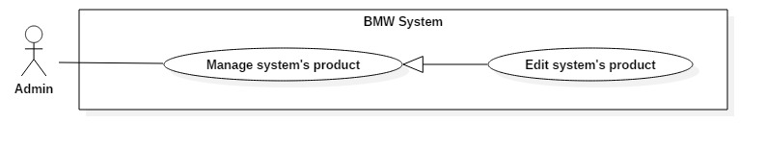**Figure 26: <Admin>Edit System’s Product**

|  |  |  |  |
| --- | --- | --- | --- |
| **USE CASE – BMW0** | | | |
| **Use Case No.** | BMW19 | **Use Case Version** | 1.0 |
| **Use Case Name** | Edit System’s Product | | |
| **Author** | ThienND | | |
| **Date** | February 10, 2017 | **Priority** | Normal |
| **Actor:**   * Admin   **Summary:**   * This use case allows Admin to update product.   **Goal:**   * Admin can update product information.   **Triggers:**   * In “Xem sản phẩm” Page, Admin choose product and click on “Chỉnh sửa” button.   **Preconditions:**   * User logged in with Admin role   **Post Conditions:**   * **Success:** Product information has been updated to the system. * **Fail:** System show error message   **Main Success Scenario:**   |  |  |  | | --- | --- | --- | | Step | Actor Action | System Response | | 1 | In “Xem sản phẩm” Page, Admin choose product and click on “Chỉnh sửa” button. | System show “Sửa sản phẩm” Page | | 2 | Admin enter information below and click on “Sửa sản phẩm” button   * “Tên sản phẩm” * “Giá” * “Nhà sán xuất” * “Danh mục” * “Chỉnh sửa” button | System validate information input  [Exception 1]  System updates product into system.  System shows “Sửa sản phẩm thành công”.  System redirects to “Xem sản phẩm” Page. |   **Alternative Scenario: N/A**  **Exception:**   |  |  |  | | --- | --- | --- | | No | Actor action | System Response | | 1 | Admin do not enter require fields | System shows message “Vui lòng điền đầy đủ thông tin bắt buộc” |   **Relationships: N/A**  **Business Rules:**   * Product must belong to one category * Product must belong to one manufacturer | | | |

**Table 20: <Admin> Edit System’s Product**

**2.3.5.4 <Admin>Delete System’s Product**

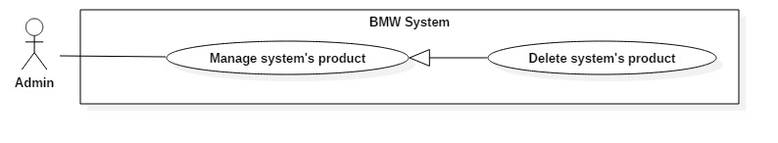**Figure 27: <Admin>Delete System’s Product**

|  |  |  |  |
| --- | --- | --- | --- |
| **USE CASE – BMW0** | | | |
| **Use Case No.** | BMW20 | **Use Case Version** | 1.0 |
| **Use Case Name** | Delete System’s Product | | |
| **Author** | VyCMT | | |
| **Date** | February 10, 2017 | **Priority** | Normal |
| **Actor:**   * Admin   **Summary:**   * This use case allows Admin to delete product.   **Goal:**   * Admin can delete products.   **Triggers:**   * In “Xem sản phẩm” Page, Admin choose product and click on “Xóa” button.   **Preconditions:**   * User logged in with Admin role   **Post Conditions:**   * **Success:** Product information has been deleted to the system. * **Fail:** Show error message   **Main Success Scenario:**   |  |  |  | | --- | --- | --- | | Step | Actor Action | System Response | | 1 | In “Xem sản phẩm” Page, Admin choose product and click on “Xóa” button. | System show Dialog: Are you sure want to delete?   * “Đồng ý” button * “Hủy” button   [Alternative 1] | | 2 | Admin choose “Đồng ý” button | System delete products out of system  System show “Xóa thành công”  System redirects to “Xem sản phẩm” Page |   **Alternative Scenario:**   |  |  |  | | --- | --- | --- | | No | Actor action | System Response | | 1 | Admin choose “Hủy” button | Dialog disappear and nothing change |   **Exception: N/A**  **Relationships: N/A**  **Business Rules: N/A** | | | |

**Table 21: <Admin> Delete System’s Product**

**2.3.5.5 <Admin>Add Role**

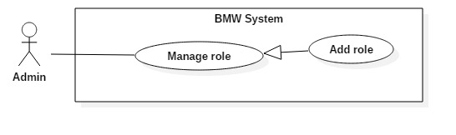

**Figure 28: <Admin>Add Role**

|  |  |  |  |
| --- | --- | --- | --- |
| **USE CASE – BMW0** | | | |
| **Use Case No.** | BMW21 | **Use Case Version** | 1.0 |
| **Use Case Name** | Add Role | | |
| **Author** | ThienND | | |
| **Date** | February 10, 2017 | **Priority** | Normal |
| **Actor:**   * Admin   **Summary:**   * This use case allows Admin to add role to user.   **Goal:**   * Admin can add role to user.   **Triggers:**   * In “Quản lý quyền” Page, Admin click on “Tạo quyền” button.   **Preconditions:**   * User logged in with Admin role   **Post Conditions:**   * **Success:** New role has been deleted to the system. * **Fail: N/A**   **Main Success Scenario:**   |  |  |  | | --- | --- | --- | | Step | Actor Action | System Response | | 1 | In “Quản lý quyền” Page, Admin click on “Tạo quyền” button. | System show “Quản lý quyền” Paged | | 2 | Admin enter information below and click on “Tạo quyền” button   * “Tên quyền” * “Tạo quyền” button | System insert role into system  System show “Quyền đã được tạo thành công”  System redirect to “Quản lý quyền” Page |   **Alternative Scenario: N/A**  **Exception: N/A**  **Relationships: N/A**  **Business Rules: N/A** | | | |

**Table 22: <Admin> Add Role**

**2.3.5.6 <Admin>Edit Role**

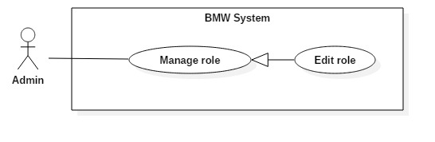

**Figure 29: <Admin>Edit Role**

|  |  |  |  |
| --- | --- | --- | --- |
| **USE CASE – BMW0** | | | |
| **Use Case No.** | BMW22 | **Use Case Version** | 1.0 |
| **Use Case Name** | Edit Role | | |
| **Author** | ThienND | | |
| **Date** | February 10, 2017 | **Priority** | Normal |
| **Actor:**   * Admin   **Summary:**   * This use case allows Admin to edit role.   **Goal:**   * Admin can edit roles.   **Triggers:**   * In “Quản lý quyền” Page, Admin click on role, click on “Sửa quyền” button.   **Preconditions:**   * User logged in with Admin role   **Post Conditions:**   * **Success:** Role has been updated to the system. * **Fail:** System show error message   **Main Success Scenario:**   |  |  |  | | --- | --- | --- | | Step | Actor Action | System Response | | 1 | In “Quản lý quyền” Page, Admin click on “Sửa quyền” button. | System show “Sửa quyền” Page | | 2 | Admin enter information below and click on “Sửa quyền” button   * “Tên quyền” * “Sửa quyền” button | System update role into system  System show “Quyền đã được sửa thành công”  System redirect to “Quản lý quyền” Page |   **Alternative Scenario: N/A**  **Exception: N/A**  **Relationships: N/A**  **Business Rules: N/A** | | | |

**Table 23: <Admin> Edit Role**

**2.3.5.7 <Admin>Delete Role**

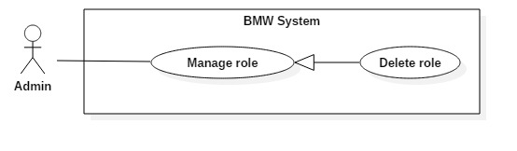

**Figure 30: <Admin>Delete Role**

|  |  |  |  |
| --- | --- | --- | --- |
| **USE CASE – BMW0** | | | |
| **Use Case No.** | BMW23 | **Use Case Version** | 1.0 |
| **Use Case Name** | Delete Role | | |
| **Author** | ThienND | | |
| **Date** | February 10, 2017 | **Priority** | Normal |
| **Actor:**   * Admin   **Summary:**   * This use case allows Admin to delete role.   **Goal:**   * Admin can delete roles.   **Triggers:**   * In “Xem chức vụ” Page, Admin choose role and click on “Xóa” button.   **Preconditions:**   * User logged in with Admin role   **Post Conditions:**   * **Success:** Role has been deleted to the system. * **Fail:** Show error message   **Main Success Scenario:**   |  |  |  | | --- | --- | --- | | Step | Actor Action | System Response | | 1 | In “Xem chức vụ” Page, Admin choose role and click on “Xóa” button. | System show Dialog: Are you sure want to delete?   * “Đồng ý” button * “Hủy” button   [Alternative 1] | | 2 | Admin choose “Đồng ý” button | System delete role out of system  System show “Xóa thành công”  System redirects to “Xem chức vụ” Page |   **Alternative Scenario:**   |  |  |  | | --- | --- | --- | | No | Actor action | System Response | | 1 | Admin choose “Hủy” button | Dialog disappear and nothing change |   **Exception: N/A**  **Relationships: N/A**  **Business Rules: N/A** | | | |

**Table 24: <Admin> Delete Role**

**3. Software System Attribute**

**3.1 Usability**

* All the texts, labels should be written in Vietnamese
* Admin, Supplier, Customer, Guest need less than one week of training
* The system should be easy to deploy and easy to use

**3.2 Reliability**

* The number of sending notification failure is 1 time per 1000 notifications.
* Timer tasks run at configured time with 100% execution rate.

**3.3 Availability**

* + - Server have back-up method to make sure that if it has problems while running then all necessary data will be protected and restore as soon as possible.
    - System should take at most 5 hours per month for backup or repairing
    - System is available 24 hours per day and 7 days per week.

**3.4 Security**

* + - Privacy: Each role of user has a specific permission to interact with system.
    - Only admin can grant permission to other roles.
    - System requires SMS verification for all users.
    - System always checks authorization and authenticated before doing anything.

**3.5 Maintainability**

* + - The system is divided into separated modules.
    - The code is easy to maintain and upgrade.

**3.6 Portability**

* The system can be deployed into many type of servers those have IIS8.
* Admin, Supplier, Customer and Guest can use application on Google Chrome version 42 or above.

**3.7 Performance**

* Requests from web application are responded in less than 10 seconds at 8 Mbps bandwidth speed and 1GHz Processing Speed of CPU.

**4. Conceptual Diagram**

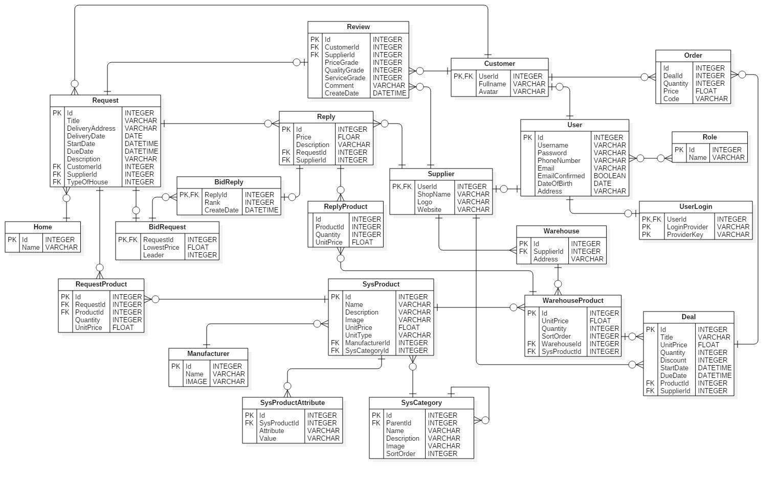

**Figure 31: Conceptual Diagram**

**Data Dictionary**

|  |  |
| --- | --- |
| Entity Name | Description |
| Request | Contain the request information |
| Customer | Contain the customer information. |
| Supplier | Contain the supplier information. |
| Order | Contain the order information. |
| Deal | Contain the deal information. |
| BidRequest | Contain the bid request information. |
| BidReply | Contain the bid reply information. |
| Warehouse | Contain the warehouse information. |
| WarehouseProduct | Contain the warehouse product information. |
| SysProduct | Contain the sys product information. |
| SysProduct Attributes | Contain the system product attributes information. |
| RequestProduct | Contain the request product information. |
| ReplyProduct | Contain the reply product information. |
| SysCategory | Contain the category information. |
| Manufacturer | Contain the manufacturer information. |
| Review | Contain the review information. |
| Reply | Contain the reply information. |
| Home | Contain the home information |
| User | Contain the user information. |
| Role | Contain the role information |
| UserLogin | Contain the user login information |

**Table 25: Conceptual Diagram Data Dictionary**

**D. Report No. 4 Software Design Description**

**1. Design Overview**

* The architectural design describes the overall architecture of the system and the architecture of each main component and subsystem
* The detailed design describes static and dynamic structure for each component and functions. It includes class diagrams, class explanations and sequence diagrams for each use cases
* The database design describes the relationships between entities and details of each entity
* Document overview:
* Section 2: gives an overall description of the system architecture design
* Section 3: gives component diagrams that describe the connection and integration of the system
* Section 4: gives the detail design description, which includes class diagram, class explanation, and sequence diagram to details the application functions
* Section 5: gives the interface design description, which includes component interface, web application interface, and mobile application design
* Section 6: describe a fully attributed Entity Relationship Diagram
* Section 7: describe the algorithms that apply in the system

**2. System Architectural Design**

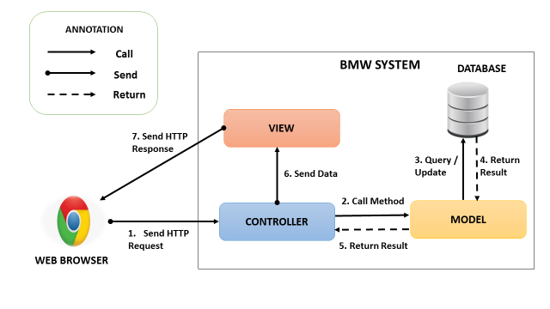

**Figure 32: System Architectural Design**

**2.1 Web application architecture description**

In Web Application, the system is developed under MVC architecture style. We choose this architecture for Web application because of following advantage

* Web application contains Web services with MVC architecture, we can separate business code with Controller and View. So we can use the business code in web service without repeat the code
* We can organize the code better for maintainability, extensibility, reusability
* In scope of 4-members team, MVC architecture makes it easier to split the big project into small modules and make it easier to assign each module for members in our team

**3. Component Diagram**

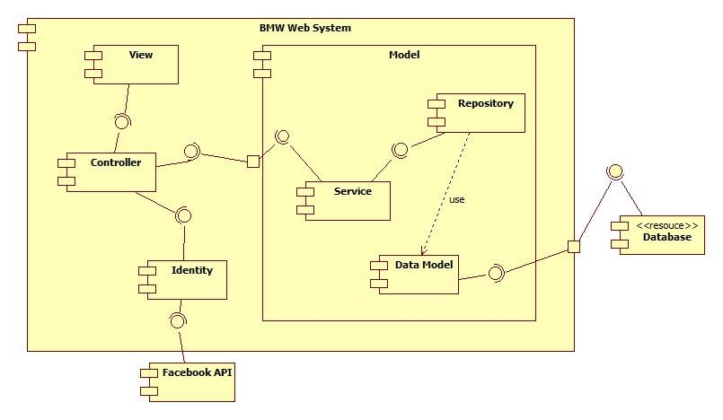

**Figure 33: Component Diagram**

|  |  |
| --- | --- |
| Component Dictionary: Describes components | |
| Facebook API | Provide API for external login using Facebook |
| Service | Common component is used to handle system’s business operations. |
| Controller | Common component is used to handle request |
| Identity | Identity is used to profile support, authentication integration |
| Repository | Component is used to handle interaction between the system and database. |
| Data Model | Entity framework |
| Database | Database support storage and manipulate data |

**Table 26: Component Dictionary**

**4. Detailed Description**

**4.1 Class Diagram**

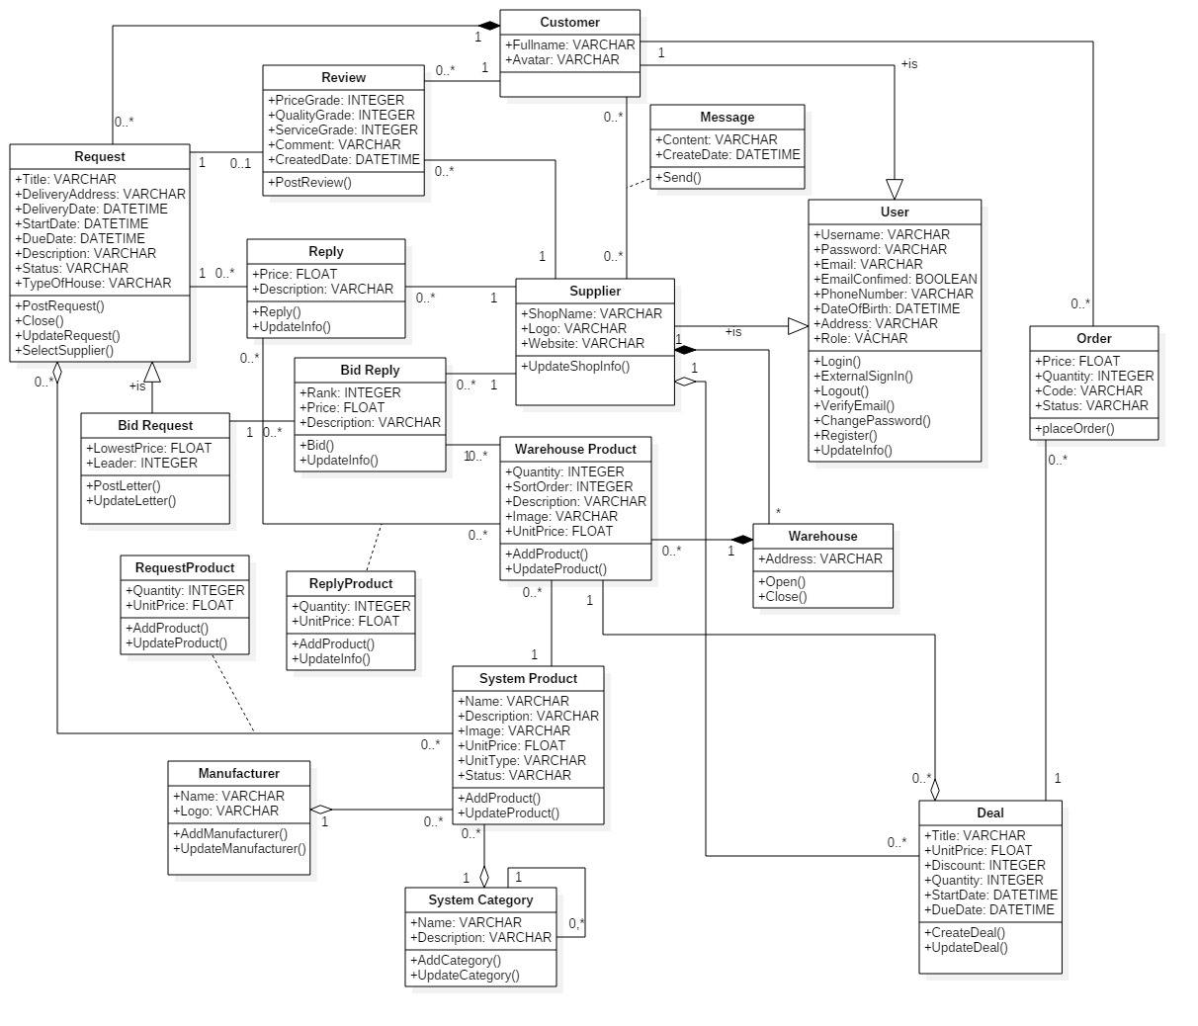

**Figure 33: Class Diagram**

|  |  |  |
| --- | --- | --- |
| **Class Dictionary: Describe Classes** | | |
| **Class name** | **Mapping column with conceptual diagram** | **Description** |
| Request | Request | Contains the information of request. |
| Bid Request | BidRequest | Contain the information of the bid ‘s request |
| User | N/A | Contains the information of user. |
| Customer | Customer | Contains the information of customer. |
| Supplier | Supplier | Contains the information of supplier. |
| Order | Order | Contains the information of order. |
| Deal | Deal | Contains the information of deal. |
| Message | Message | Contain the information of message. |
| Review | Review | Contains the information of review. |
| Reply | N/A | Contains the information of reply. |
| Bid Reply | BidReply | Contains the information of the bid’s reply. |
| Warehouse | Warehouse | Contains the information of the warehouse. |
| Warehouse Product | WarehouseProduct | Contains the information of the warehouse‘s product. |
| Reply Product | ReplyProduct | Contains the information of the product of the reply. |
| Request Product | RequestProduct | Contains the information of the product of the request. |
| System Product | SysProduct | Contains the information of the system’s product. |
| System Categories | SysCategory | Contains the information of the system’s categories. |
| Manufacturer | Manufacture | Contains the information of the manufacturer. |

**Table 27: Describe Class**

**4.2 Class Diagram Explanation**

* + 1. **Request**

**Attributes**

|  |  |  |  |
| --- | --- | --- | --- |
| **Attribute** | **Type** | **Visibility** | **Description** |
| Title | String | Public | Title of the request |
| DeliveryAddress | String | Public | Delivery Address of the request |
| DeliveryDate | Datetime | Public | Delivery Date of the request |
| StartDate | Datetime | Public | Start Date of the request |
| DueDate | Datetime | Public | Due Date of the request |
| Description | String | Public | Description of the request |
| Status | String | Public | Status of the request |
| TypeOfHouse | String | Public | TypeOfHouse of the request |

**Table 28: Request Attributes**

**Methods**

|  |  |  |  |
| --- | --- | --- | --- |
| **Method** | **Return type** | **Visibility** | **Description** |
| Post Request |  | Public | Post a new request |
| Close |  | Public | Close the existing request |
| Update Request |  | Public | Update the existing request |
| Select Supplier |  | Public | Select the supplier |

**Table 29: Request Methods**

* + 1. **Bid Request**

**Attributes**

|  |  |  |  |
| --- | --- | --- | --- |
| **Attribute** | **Type** | **Visibility** | **Description** |
| LowestPrice | Double | Public | Lowest price of the bid request |
| Leader | Integer | Public | The supplier has lowest price |

**Table 30: Bid Request Attributes**

**Methods**

|  |  |  |  |
| --- | --- | --- | --- |
| **Method** | **Return type** | **Visibility** | **Description** |
| PostBid |  | Public | Post a new bid request |
| UpdateBid |  | Public | Update the existing request |

**Table 31: Bid Request Methods**

* + 1. **User**

**Attributes**

|  |  |  |  |
| --- | --- | --- | --- |
| **Attribute** | **Type** | **Visibility** | **Description** |
| Username | String | Public | User’s username |
| Password | String | Public | User’s password |
| Email | String | Public | User’s email |
| EmailConfirmed | Bool | Public | Email confirm |
| PhoneNumber | String | Public | User’s phone number |
| DateOfBirth | Datetime | Public | User’s date of birth |
| Address | String | Public | User’s address |
| Role | String | Public | User’s role |

**Table 32: User Attributes**

**Methods**

|  |  |  |  |
| --- | --- | --- | --- |
| **Method** | **Return type** | **Visibility** | **Description** |
| Login |  | Public | User login |
| ExternalSignIn |  | Public | Facebook sign in |
| Logout |  | Public | User logout |
| VerifyEmail |  | Public | Verify user’s email |
| ChangePassword |  | Public | Change user’s password |
| Register |  | Public | Register user |
| UpdateInfo |  | Public | Update user’s info |

**Table 33: User Methods**

* + 1. **Customer**

**Attributes**

|  |  |  |  |
| --- | --- | --- | --- |
| **Attribute** | **Type** | **Visibility** | **Description** |
| FullName | String | Public | Lowest price of the bid request |
| Avatar | String | Public | ID of the supplier has lowest price |

**Table 34: Customer Attributes**

* + 1. **Supplier**

**Attributes**

|  |  |  |  |
| --- | --- | --- | --- |
| **Attribute** | **Type** | **Visibility** | **Description** |
| ShopName | String | Public | Name of the supplier’s shop |
| Logo | String | Public | Logo of the supplier |
| Website | String | Public | Website of the supplier |

**Table 35: Supplier Attributes**

**Methods**

|  |  |  |  |
| --- | --- | --- | --- |
| **Method** | **Return type** | **Visibility** | **Description** |
| UpdateShopInfo |  | Public | Update the supplier’s shop info |

**Table 36: Supplier Methods**

* + 1. **Order**

**Attributes**

|  |  |  |  |
| --- | --- | --- | --- |
| **Attribute** | **Type** | **Visibility** | **Description** |
| Price | Double | Public | Price of the order |
| Quantity | Integer | Public | Quantity of the order |
| Code | String | Public | Code of the order |
| Status | String | Public | Status of the order |

**Table 37: Order Attributes**

**Methods**

|  |  |  |  |
| --- | --- | --- | --- |
| **Method** | **Return type** | **Visibility** | **Description** |
| PlaceOrder |  | Public | Make order |

**Table 38: Order Methods**

* + 1. **Deal**

**Attributes**

|  |  |  |  |
| --- | --- | --- | --- |
| **Attribute** | **Type** | **Visibility** | **Description** |
| Title | String | Public | Title of the deal |
| UnitPrice | Double | Public | Unit price of the deal |
| Discount | Integer | Public | Discount of the deal |
| Quantity | Integer | Public | Quantity of the deal |
| StartDate | Date | Public | Beginning date of the deal |
| DueDate | Date | Public | End date of the deal |

**Table 39: Deal Attributes**

**Methods**

|  |  |  |  |
| --- | --- | --- | --- |
| **Method** | **Return type** | **Visibility** | **Description** |
| CreateDeal |  | Public | Create a new deal |
| UpdateDeal |  | Public | Update the existing deal |

**Table 40: Deal Methods**

* + 1. **Message**

**Attributes**

|  |  |  |  |
| --- | --- | --- | --- |
| **Attribute** | **Type** | **Visibility** | **Description** |
| Content | String | Public | Content of the message |
| CreateDate | Date | Public | Create date of the message |

**Table 41: Supplier Attributes**

**Methods**

|  |  |  |  |
| --- | --- | --- | --- |
| **Method** | **Return type** | **Visibility** | **Description** |
| Send |  | Public | Send the message |

**Table 42: Supplier Methods**

* + 1. **Review**

**Attributes**

|  |  |  |  |
| --- | --- | --- | --- |
| **Attribute** | **Type** | **Visibility** | **Description** |
| PriceGrade | Integer | Public | Price grade of the review |
| QuantityGrade | Integer | Public | Quantity grade of the review |
| SericeGrade | Integer | Public | Service grade of the review |
| Comment | String | Public | Comment of the review |
| CreatedDate | Date | Public | Created date of the review |

**Table: Review Attributes**

**Methods**

|  |  |  |  |
| --- | --- | --- | --- |
| **Method** | **Return type** | **Visibility** | **Description** |
| PostReview |  | Public | Post the review |

**Table 43: Review Methods**

* + 1. **Reply**

**Attributes**

|  |  |  |  |
| --- | --- | --- | --- |
| **Attribute** | **Type** | **Visibility** | **Description** |
| Price | String | Public | Price of the reply |
| Description | String | Public | Description of the reply |

**Table 44: Reply Attributes**

**Methods**

|  |  |  |  |
| --- | --- | --- | --- |
| **Method** | **Return type** | **Visibility** | **Description** |
| Reply |  | Public | Supplier reply the request |
| UpdateInfo |  | Public | Supplier update the reply’s info |

**Table 45: Reply Methods**

* + 1. **Bid Reply**

**Attributes**

|  |  |  |  |
| --- | --- | --- | --- |
| **Attribute** | **Type** | **Visibility** | **Description** |
| ShopName | String | Public | Supplier’s shop name |
| Logo | String | Public | Supplier’s logo |
| Website | String | Public | Supplier’s website |

**Table 46: Supplier Attributes**

**Methods**

|  |  |  |  |
| --- | --- | --- | --- |
| **Method** | **Return type** | **Visibility** | **Description** |
| UpdateShopInfo |  | Public | Update the supplier’s shop info |

**Table 47: Supplier Methods**

* + 1. **Warehouse**

**Attributes**

|  |  |  |  |
| --- | --- | --- | --- |
| **Attribute** | **Type** | **Visibility** | **Description** |
| Address | String | Public | Address of the warehouse |

**Table 48: Warehouse Attributes**

**Methods**

|  |  |  |  |
| --- | --- | --- | --- |
| **Method** | **Return type** | **Visibility** | **Description** |
| Open |  | Public | Open the warehouse |
| Close |  | Public | Close the warehouse |

**Table 49: Warehouse Methods**

* + 1. **Warehouse Product**

**Attributes**

|  |  |  |  |
| --- | --- | --- | --- |
| **Attribute** | **Type** | **Visibility** | **Description** |
| Quantity | Integer | Public | Quantity of the warehouse’s product |
| SortOrder | Integer | Public | Sort order of the warehouse’s product |
| Description | String | Public | Description of the warehouse’s product |
| Image | String | Public | Image of the warehouse’s product |
| UnitPrice | Double | Public | Unit price of the warehouse’s product |

**Table 50: Warehouse Product Attributes**

**Methods**

|  |  |  |  |
| --- | --- | --- | --- |
| **Method** | **Return type** | **Visibility** | **Description** |
| AddProduct |  | Public | Add product to warehouse |
| UpdateProduct |  | Public | Update product in warehouse |

**Table 51: Warehouse Product Methods**

* + 1. **Reply Product**

**Attributes**

|  |  |  |  |
| --- | --- | --- | --- |
| **Attribute** | **Type** | **Visibility** | **Description** |
| Quantity | String | Public | Quantity of the reply’s product |

**Table 52: Reply Product Attributes**

**Methods**

|  |  |  |  |
| --- | --- | --- | --- |
| **Method** | **Return type** | **Visibility** | **Description** |
| AddProduct |  | Public | Add product to reply |
| UpdateShopInfo |  | Public | Update product in reply |

**Table 53: Reply Product Methods**

* + 1. **Request Product**

**Attributes**

|  |  |  |  |
| --- | --- | --- | --- |
| **Attribute** | **Type** | **Visibility** | **Description** |
| Quantity | Integer | Public | Quantity of the request’s product |
| UnitPrice | Double | Public | Unit price of the request’s product |

**Table 54: Request Product Attributes**

**Methods**

|  |  |  |  |
| --- | --- | --- | --- |
| **Method** | **Return type** | **Visibility** | **Description** |
| AddProduct |  | Public | Add product to request |
| UpdateProduct |  | Public | Update product in request |

**Table 55: Request Product Methods**

* + 1. **System Product**

**Attributes**

|  |  |  |  |
| --- | --- | --- | --- |
| **Attribute** | **Type** | **Visibility** | **Description** |
| Name | String | Public | System product’s name |
| Description | String | Public | System product’s description |
| Image | String | Public | System product’s image |
| UnitPrice | Double | Public | System product’s unit price |
| UnitType | String | Public | System product’s unit type |
| Status | String | Public | System product’s status |

**Table 57: System Product Attributes**

**Methods**

|  |  |  |  |
| --- | --- | --- | --- |
| **Method** | **Return type** | **Visibility** | **Description** |
| AddProduct |  | Public | Add system product |
| UpdateProduct |  | Public | Update existing sytem product |

**Table 58: System Product Methods**

* + 1. **System Categories**

**Attributes**

|  |  |  |  |
| --- | --- | --- | --- |
| **Attribute** | **Type** | **Visibility** | **Description** |
| Name | String | Public | System categories’s name |
| Description | String | Public | System categories’s description |

**Table 59: System Categories Attributes**

**Methods**

|  |  |  |  |
| --- | --- | --- | --- |
| **Method** | **Return type** | **Visibility** | **Description** |
| AddCategories |  | Public | Add new system’s categories |
| UpdateCategories |  | Public | Update existing system’s categories |

**Table 60: System Categories Methods**

* + 1. **Manufacturer**

**Attributes**

|  |  |  |  |
| --- | --- | --- | --- |
| **Attribute** | **Type** | **Visibility** | **Description** |
| Name | String | Public | Manufacturer’s name |
| Logo | String | Public | Manufacturer’s logo |

**Table 61: Manufacturer Attributes**

**Methods**

|  |  |  |  |
| --- | --- | --- | --- |
| **Method** | **Return type** | **Visibility** | **Description** |
| AddManufacturer |  | Public | Add new manufacturer |
| UpdateManufacturer |  | Public | Update the existing manufacturer |

**Table 62: Manufacturer Methods**

**4.3 Interaction Diagram**

**4.3.1 Guest**

**4.3.2 Customer**

**4.3.2.1 Create Request**

**Summary**: This diagram show process when customer create request

**Figure 35 :< Sequence Diagram> Create Request**

**4.3.2.2 Create Order**

**Summary**: This diagram show process when customer create order

**Figure 35 :< Sequence Diagram> Create Order**

**4.3.2.3 Update Order**

**Summary**: This diagram show process when customer update order

**Figure 35 :< Sequence Diagram> Update Order**

**4.3.2.4 Delete Order**

**Summary**: This diagram show process when customer delete order

**Figure 35 :< Sequence Diagram> Delete Order**

**4.3.3 Supplier**

**4.3.3.1 Add Shop’s Product**

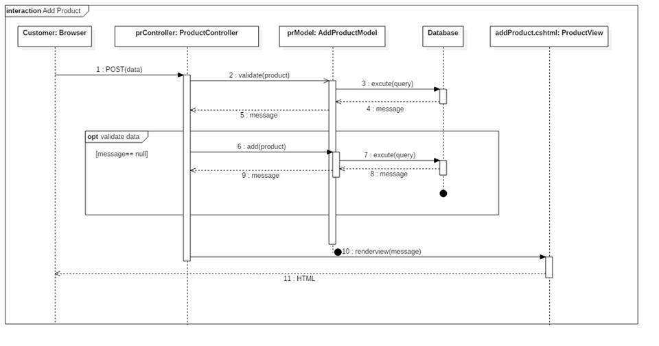**Summary**: This diagram show process when supplier add product to shop

**Figure 34 :< Sequence Diagram> Add Shop’s Product**

**4.3.3.2 Create Reply**

**Summary**: This diagram show process when supplier reply normal request

**Figure 35 :< Sequencec Diagram> Create Reply**

**4.3.3.3 Place a bid**

**Summary**: This diagram show process when supplier place a bid request

**Figure 35 :< Sequencec Diagram> Place A Bid**

**4.3.4 Admin**

**5. Interface**

**5.1 Component interface**

| **Signature** | **Description** | **Input** | **Output** | **Output Format** | **Exception** |
| --- | --- | --- | --- | --- | --- |
| **function** void Insert(T entity) | Insert new entity to database | An entity | Void |  | SQLException |
| **function** void Delete(T entity) | Delete an entity | An entity | Void |  | SQLException |
| **Function** IQueryable<T> SearchFor (Expression<Func<T,bool>> predicate) | Search entity in database that match the expressiong | An expression describe the entity | IQueryable<T> |  | SQLException |
| **function** IQueryable<T> getAll() | Get all entities of this type | Void | IQueryable<T> |  | SQLException |

**5.2 User Interface Design**

**5.2.1 Guest Interface Design**

**5.2.1.1 Login**

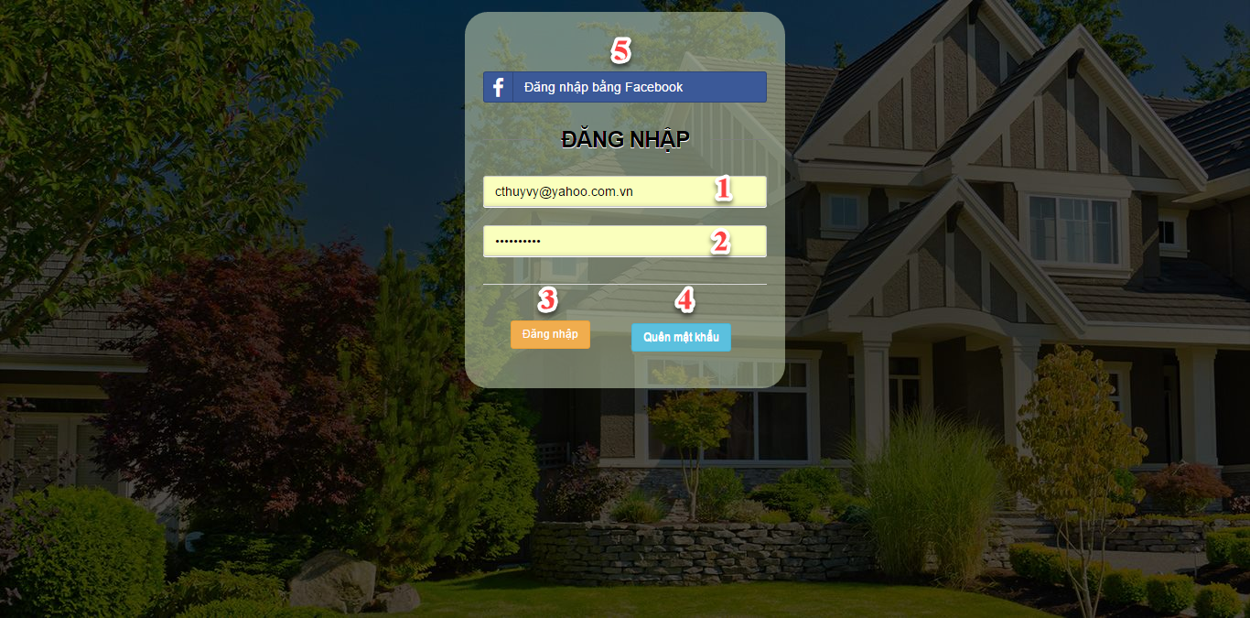

**Figure 34: Login**

**Fields**

|  |  |  |  |  |  |  |  |
| --- | --- | --- | --- | --- | --- | --- | --- |
| No | Field Name | Description | Read only | Mandatory | Control type | Data type | Length |
| 1 | Email | Account email | No | Yes | Textbox | String | N/A |
| 2 | Password | Account password | No | Yes | Password | String | N/A |

**Buttons/Hyperlinks**

|  |  |  |  |  |
| --- | --- | --- | --- | --- |
| No | Function | Description | Validation | Outcome |
| 3 | Login | Sign in to system | Validate Email and Password | Open specific page with specific account |
| 4 | Forgot password | Recover password | Validate Email | Redirect to Reset Password page |
| 5 | Login using Facebook | External login | N/A | Open specific page with specific account |

**5.2.1.2 Forgot password**

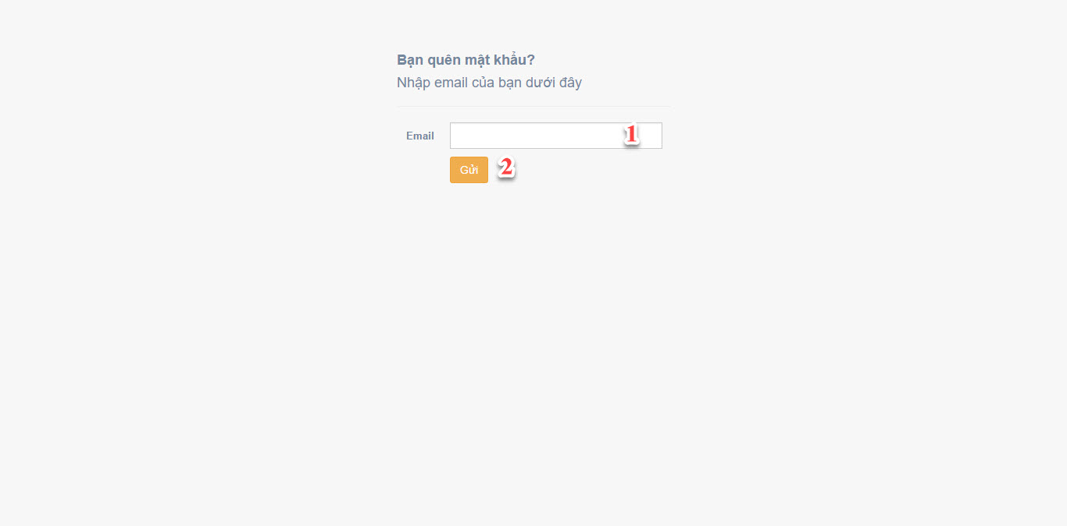

**Figure 35: Forgot password**

**Fields**

|  |  |  |  |  |  |  |  |
| --- | --- | --- | --- | --- | --- | --- | --- |
| No | Field Name | Description | Read only | Mandatory | Control type | Data type | Length |
| 1 | Email | Account email | No | Yes | Textbox | String | N/A |

**Buttons/Hyperlinks**

|  |  |  |  |  |
| --- | --- | --- | --- | --- |
| No | Function | Description | Validation | Outcome |
| 2 | Fogot password | Recover password | Validate Email | Redirect to Reset Password page |

**5.2.1.3 Reset password**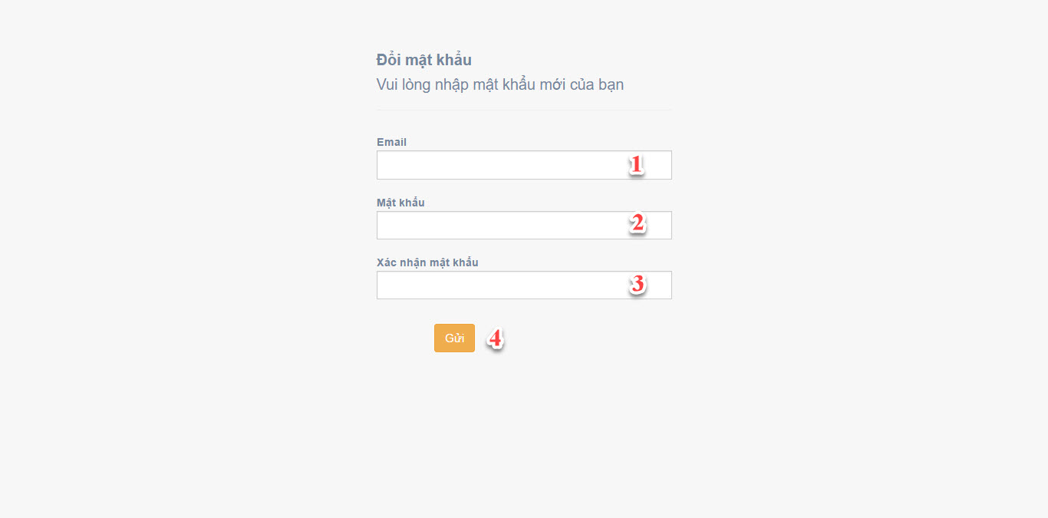

**Figure 36: Reset password**

**Fields**

|  |  |  |  |  |  |  |  |
| --- | --- | --- | --- | --- | --- | --- | --- |
| No | Field Name | Description | Read only | Mandatory | Control type | Data type | Length |
| 1 | Email | Account email | No | Yes | Textbox | String | N/A |
| 2 | Password | Account password | No | Yes | Password | String | N/A |
| 3 | Confirm Password | Confirm password | No | Yes | Password | String | N/A |

**Buttons/Hyperlinks**

|  |  |  |  |  |
| --- | --- | --- | --- | --- |
| No | Function | Description | Validation | Outcome |
| 4 | Reset password | Reset password |  | Redirect to Home Page |

**5.2.1.4 Register**

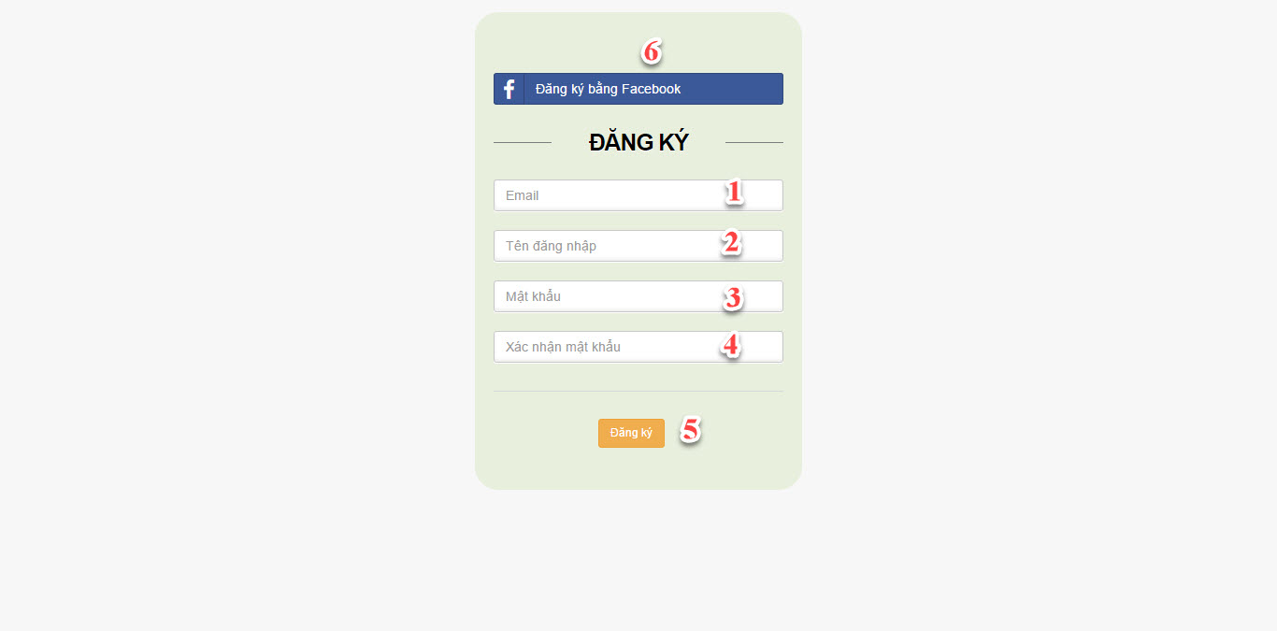

**Figure 37: Register**

**Fields**

|  |  |  |  |  |  |  |  |
| --- | --- | --- | --- | --- | --- | --- | --- |
| No | Field Name | Description | Read only | Mandatory | Control type | Data type | Length |
| 1 | Email | Account email | No | Yes | Textbox | String | N/A |
| 2 | Username | Account Email | No | Yes | Textbox | String | N/A |
| 3 | Password | Account Password | No | Yes | Password | String | N/A |
| 4 | Confirm Password | Confirm Password | No | Yes | Password | String | N/A |

**Buttons/Hyperlinks**

|  |  |  |  |  |
| --- | --- | --- | --- | --- |
| No | Function | Description | Validation | Outcome |
| 5 | Register | Create new account | Validate Email, User, Password and Confirm Password | Redirect to Home Page |
| 6 | Register using Facebook | External Register | N/A | Tranfer to Home Page |

* + 1. **Customer Interface Design**
       1. 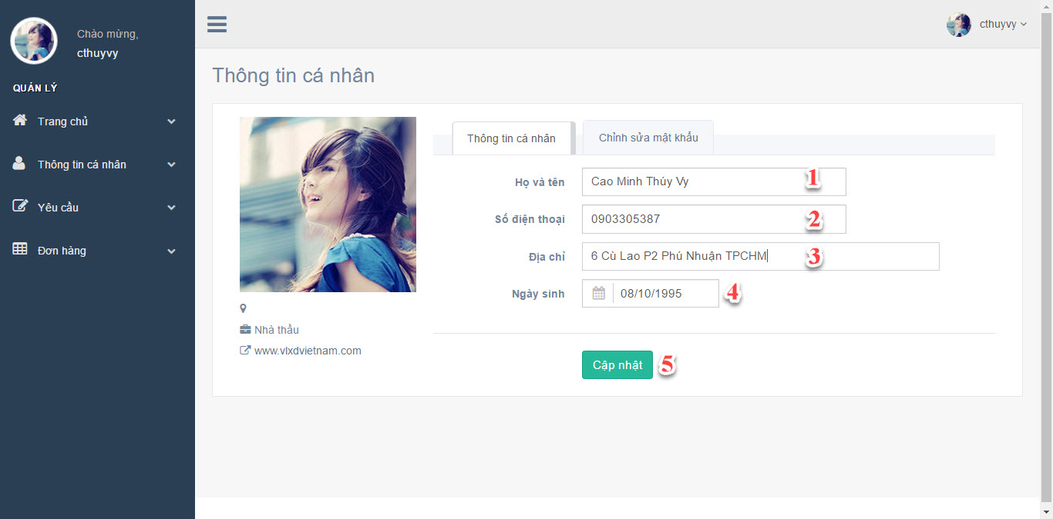**Edit Profile**

**Figure 38: Edit Profile**

**Fields**

|  |  |  |  |  |  |  |  |
| --- | --- | --- | --- | --- | --- | --- | --- |
| No | Field Name | Description | Read only | Mandatory | Control type | Data type | Length |
| 1 | Full Name | Account full name | No | Yes | Textbox | String | N/A |
| 2 | Phone Number | Account phone number | No | Yes | Textbox | String | N/A |
| 3 | Address | Account address | No | Yes | Textbox | String | N/A |
| 4 | Date Of Birth | Accoutn date of birth | No | Yes | Textbox | Date Time | N/A |

**Buttons/Hyperlinks**

|  |  |  |  |  |
| --- | --- | --- | --- | --- |
| No | Function | Description | Validation | Outcome |
| 5 | Update | Update profile to system | Validate DateOfBirth | Display successful message |

* + - 1. **Change Password**

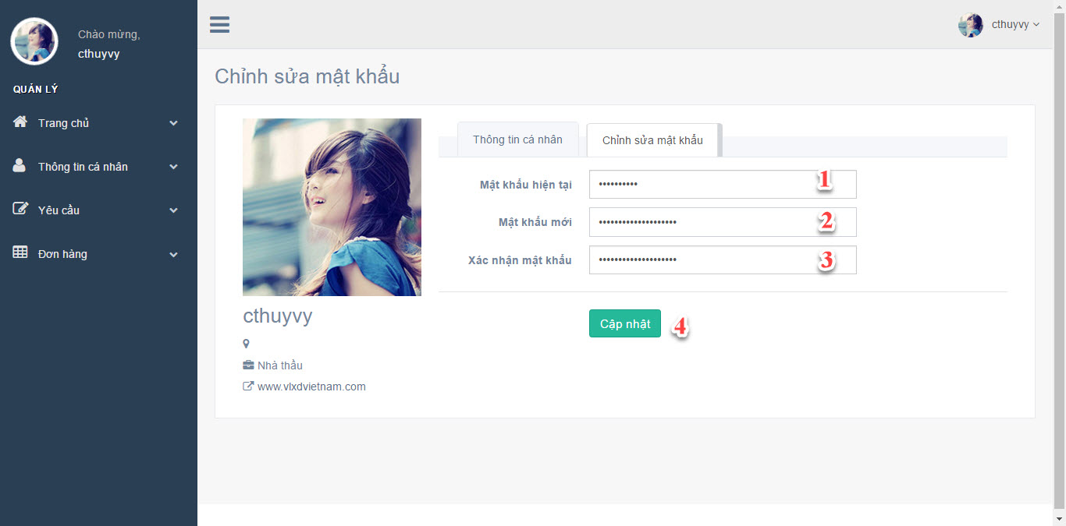

**Figure 39: Change Password**

**Fields**

|  |  |  |  |  |  |  |  |
| --- | --- | --- | --- | --- | --- | --- | --- |
| No | Field Name | Description | Read only | Mandatory | Control type | Data type | Length |
| 1 | Current Password | Account current password | No | Yes | Password | String | N/A |
| 2 | New Password | Account new password | No | Yes | Password | String | N/A |
| 3 | Confirm Password | Confirm new password | No | Yes | Password | String | N/A |

**Buttons/Hyperlinks**

|  |  |  |  |  |
| --- | --- | --- | --- | --- |
| No | Function | Description | Validation | Outcome |
| 5 | Update | Update new password to user profile | N/A | Display successful message |

* + - 1. **Create Bid Request**

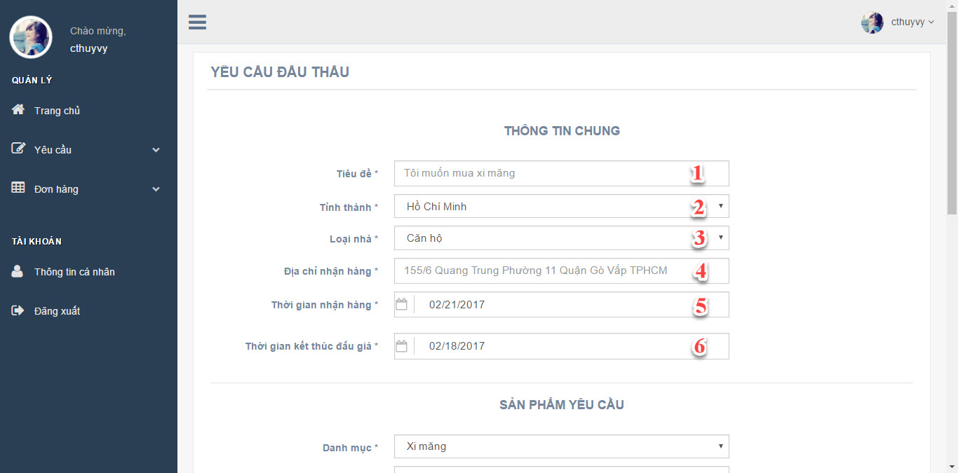

**Figure 40: Create Bid Request_1**

**Fields**

|  |  |  |  |  |  |  |  |
| --- | --- | --- | --- | --- | --- | --- | --- |
| No | Field Name | Description | Read only | Mandatory | Control type | Data type | Length |
| 1 | Title | Title of request | No | Yes | TextBox | String | N/A |
| 2 | Region | Region in VietNam | No | Yes | DropDownList | String | N/A |
| 3 | TypeOfHouse | Type of house | No | Yes | DropDownList | String | N/A |
| 4 | Delivery Address | Delivery Address | No | Yes | TextBox | String | N/A |
| 5 | Delivery Date | Delivery Date | No | Yes | DateTime | DateTime | N/A |
| 6 | Request Due Date | Request Due Date | No | Yes | DateTime | DateTime | N/A |

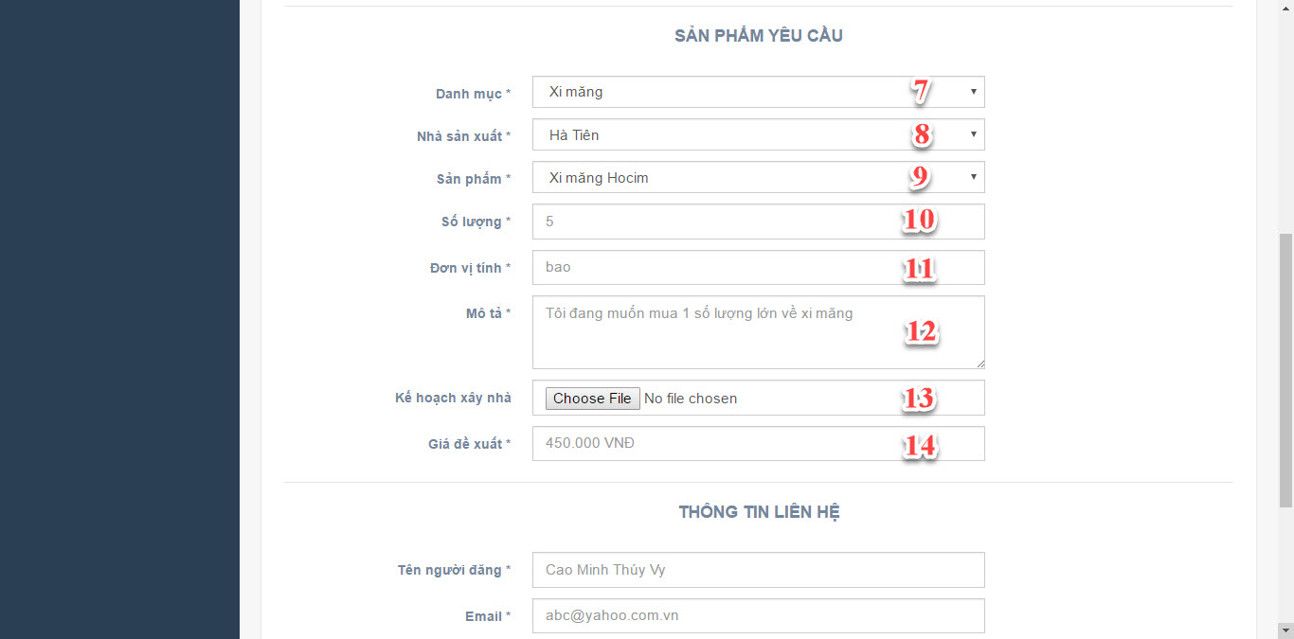

**Figure 41: Create Bid Request_2**

**Fields**

|  |  |  |  |  |  |  |  |
| --- | --- | --- | --- | --- | --- | --- | --- |
| No | Field Name | Description | Read only | Mandatory | Control type | Data type | Length |
| 7 | Category | Product Category | No | Yes | DropDownList | String | N/A |
| 8 | Manufacture | Product Manufacture | No | Yes | DropDownList | String | N/A |
| 9 | Product | Product Name | No | Yes | DropDownList | String | N/A |
| 10 | Quantity | Product Quantity | No | Yes | TextBox | String | N/A |
| 11 | Unit Type | Product Unit Type | No | Yes | TextBox | String | N/A |
| 12 | Description | Product Description | No | Yes | TextBox | String | N/A |
| 13 | Plan | Buidling plan | No | Yes | File | File | N/A |
| 14 | Starting price | Product starting price | No | Yes | TextBox | Double | N/A |

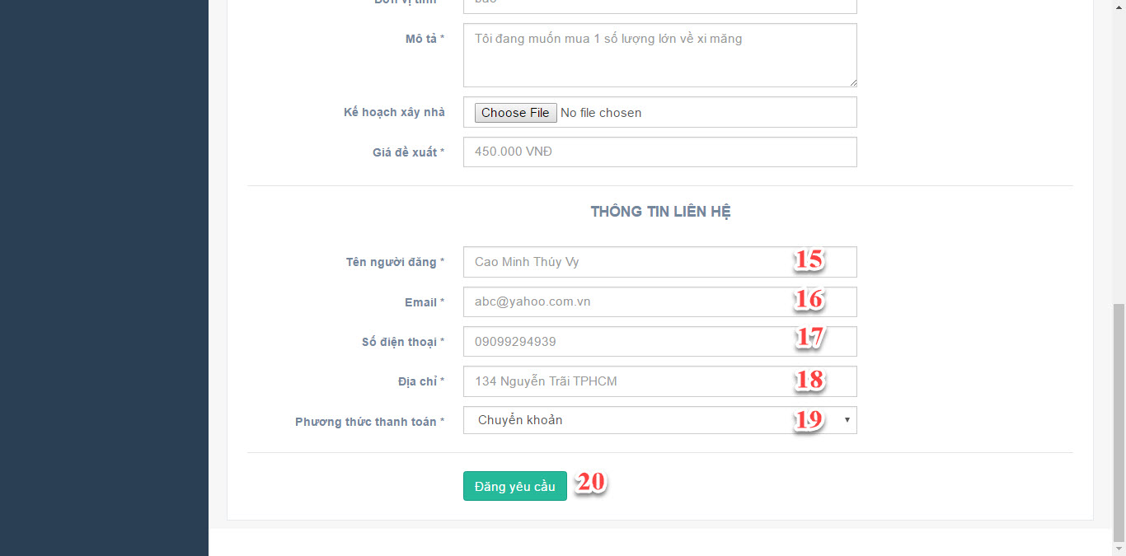

**Figure 42: Create Bid Request_3**

**Fields**

|  |  |  |  |  |  |  |  |
| --- | --- | --- | --- | --- | --- | --- | --- |
| No | Field Name | Description | Read only | Mandatory | Control type | Data type | Length |
| 15 | Name | Customer Name | No | Yes | TextBox | String | N/A |
| 16 | Email | Customer Email | No | Yes | TextBox | String | N/A |
| 17 | Phone Number | Customer Phone number | No | Yes | TextBox | Integer | N/A |
| 18 | Address | Customer Address | No | Yes | TextBox | String | N/A |
| 19 | Payment Method | Payment Method | No | Yes | DropDownList | String | N/A |

**Buttons/Hyperlinks**

|  |  |  |  |  |
| --- | --- | --- | --- | --- |
| No | Function | Description | Validation | Outcome |
| 20 | Create Request | Create bid request | Validate Delivery Date, Request End Date | Redirect to Mange Request Page |

* + - 1. **Create Normal Request**

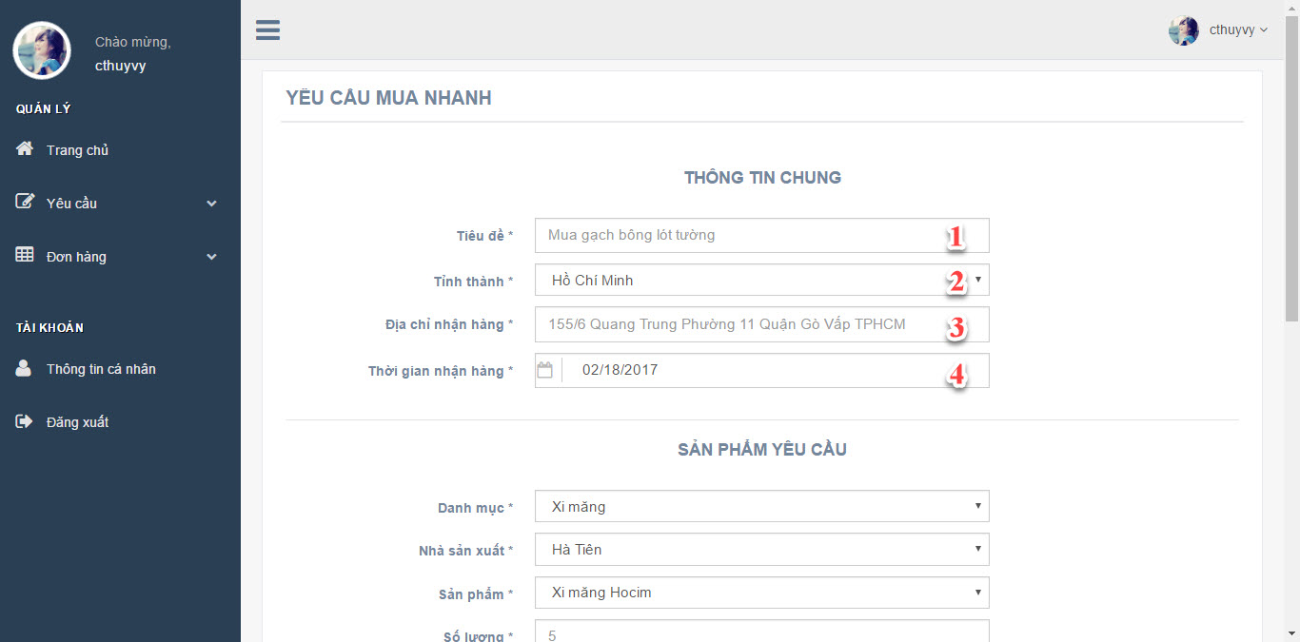

**Figrue 43: Create Normal Request_1**

**Fields**

|  |  |  |  |  |  |  |  |
| --- | --- | --- | --- | --- | --- | --- | --- |
| No | Field Name | Description | Read only | Mandatory | Control type | Data type | Length |
| 1 | Title | Request title | No | Yes | TextBox | String | N/A |
| 2 | Region | Region in VietNam | No | Yes | TextBox | String | N/A |
| 3 | Delivery Address | Customer Delivery address | No | Yes | TextBox | String | N/A |
| 4 | Delivery Date | Request Delivery Date | No | Yes | DateTime | DateTime | N/A |

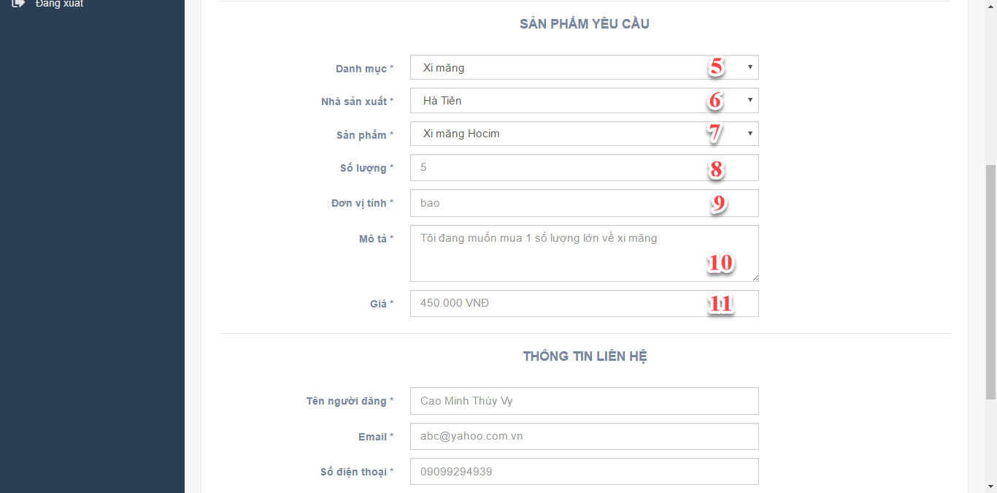

**Figrue 44: Create Normal Request_2**

**Fields**

|  |  |  |  |  |  |  |  |
| --- | --- | --- | --- | --- | --- | --- | --- |
| No | Field Name | Description | Read only | Mandatory | Control type | Data type | Length |
| 5 | Category | Product Category | No | Yes | DropDownList | String | N/A |
| 6 | Manufacture | Product Manufacture | No | Yes | DropDownList | String | N/A |
| 7 | Product | Product Name | No | Yes | DropDownList | String | N/A |
| 8 | Quantity | Product Quantity | No | Yes | TextBox | Integer | N/A |
| 9 | Unit Type | Product Unit type | No | Yes | TextBox | String | N/A |
| 10 | Description | Product Description | No | Yes | TextBox | String | N/A |
| 11 | Price | Produc price | No | Yes | TextBox | Double | N/A |

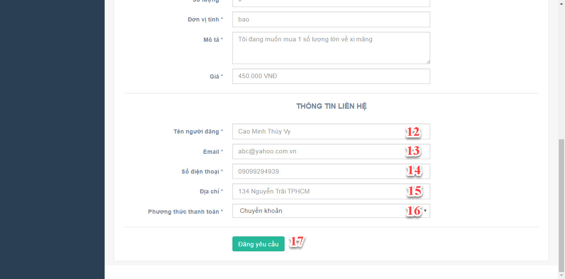

**Figrue 45: Create Normal Request_3**

**Fields**

|  |  |  |  |  |  |  |  |
| --- | --- | --- | --- | --- | --- | --- | --- |
| No | Field Name | Description | Read only | Mandatory | Control type | Data type | Length |
| 12 | Name | Customer Name | No | Yes | TextBox | String | N/A |
| 13 | Email | Customer Email | No | Yes | TextBox | String | N/A |
| 14 | Phone Number | Customer Phone number | No | Yes | TextBox | Integer | N/A |
| 15 | Address | Customer Address | No | Yes | TextBox | String | N/A |
| 16 | Payment Method | Payment Method | No | Yes | DropDownList | String | N/A |

**Buttons/Hyperlinks**

|  |  |  |  |  |
| --- | --- | --- | --- | --- |
| No | Function | Description | Validation | Outcome |
| 17 | Create Request | Create Normal Request | N/A | Redirect to Manage Request Page |

* + - 1. **Choose Supplier**

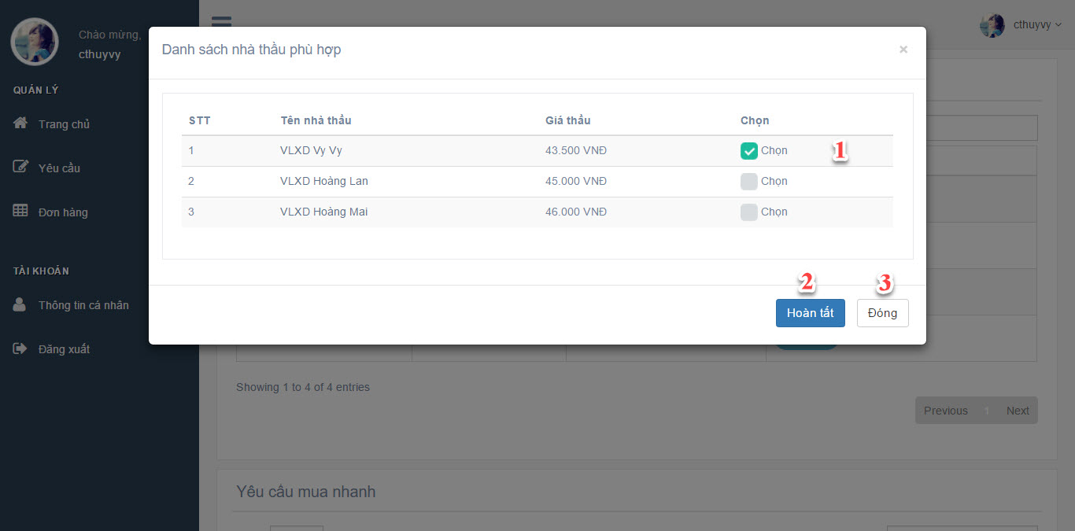

**Figure 46: Choose Supplier**

**Fields**

|  |  |  |  |  |  |  |  |
| --- | --- | --- | --- | --- | --- | --- | --- |
| No | Field Name | Description | Read only | Mandatory | Control type | Data type | Length |
| 1 | Choose Supplier | Choose Supplier | No | Yes | CheckBox | N/A | N/A |

**Buttons/Hyperlinks**

|  |  |  |  |  |
| --- | --- | --- | --- | --- |
| No | Function | Description | Validation | Outcome |
| 2 | Finish | Finish choosing supplier | N/A | Redirect to Request Page |
| 3 | Close | Close dialog | N/A | Return to View Request Detail Page |

* + 1. **Supplier Interface Design**
       1. **Dashboard**

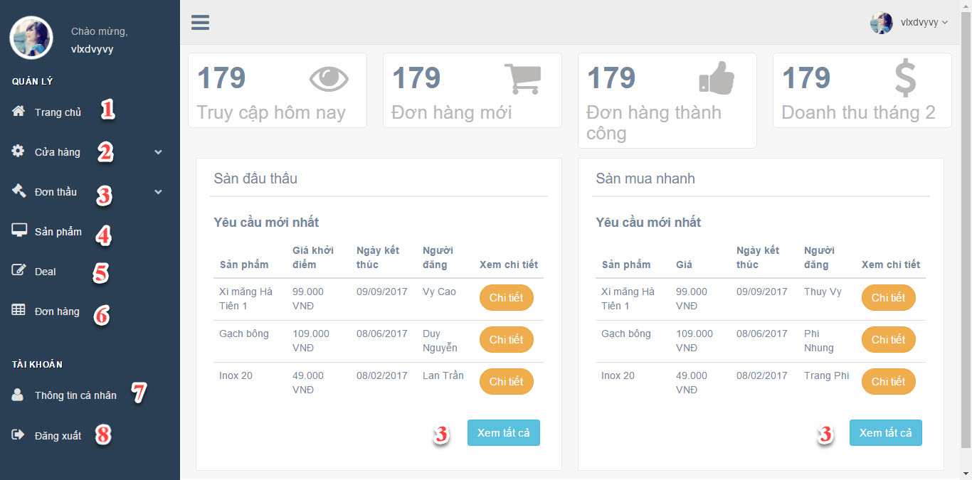

**Figure 47: Supplier Dashboard**

**Buttons/Hyperlinks**

|  |  |  |  |  |
| --- | --- | --- | --- | --- |
| No | Function | Description | Validation | Outcome |
| 1 | Dashboard | View supplier home page | N/A | Redirect to Supplier Home Page |
| 2 | Manage Shop | View manage shop page | N/A | Redirect to Manage shop Page |
| 3 | Mange Request | View mange request page | N/A | Redirect to Mange request Page |
| 4 | Mange Product | View manage product page | N/A | Redirect to Manage product Page |
| 5 | Mange Deal | View manage deal page | N/A | Redirect to Manage deal Page |
| 6 | Manage Order | View manage order page | N/A | Redirect to Manage order Page |
| 7 | Profile | View profile | N/A | Redirect to Profile Page |
| 8 | Logout | Sign out from system | N/A | Redirect to Home Page |

* + - 1. **Add Shop’s Product**

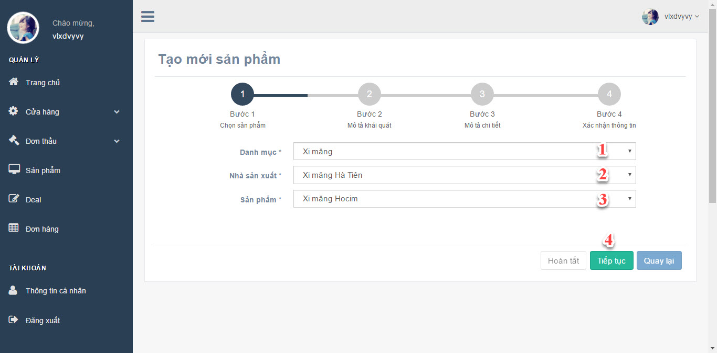

**Figure 48: Add Shop’s Product (Step 1)**

**Fields**

|  |  |  |  |  |  |  |  |
| --- | --- | --- | --- | --- | --- | --- | --- |
| No | Field Name | Description | Read only | Mandatory | Control type | Data type | Length |
| 1 | Category | Product category | No | Yes | DropdownList | String | N/A |
| 2 | Manufacture | Product manufacture | No | Yes | DropdownList | String | N/A |
| 3 | Product | Product name | No | Yes | DropdownList | String | N/A |

**Buttons/Hyperlinks**

|  |  |  |  |  |
| --- | --- | --- | --- | --- |
| No | Function | Description | Validation | Outcome |
| 4 | Move to next step | Move to next step | N/A | Move to next step |

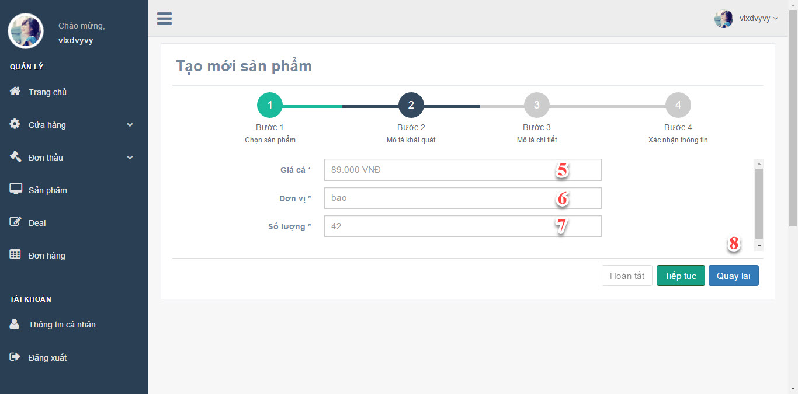

**Figure 49: Add Shop’s Product (Step 2)**

**Fields**

|  |  |  |  |  |  |  |  |
| --- | --- | --- | --- | --- | --- | --- | --- |
| No | Field Name | Description | Read only | Mandatory | Control type | Data type | Length |
| 5 | Price | Product price | No | Yes | TextBox | String | N/A |
| 6 | UnitType | Product unit type | No | Yes | TextBox | String | N/A |
| 7 | Quantity | Product quantity | No | Yes | TextBox | Integer | N/A |

**Buttons/Hyperlinks**

|  |  |  |  |  |
| --- | --- | --- | --- | --- |
| No | Function | Description | Validation | Outcome |
| 8 | Move to previous step | Move to previous step | N/A | Move to previous step |

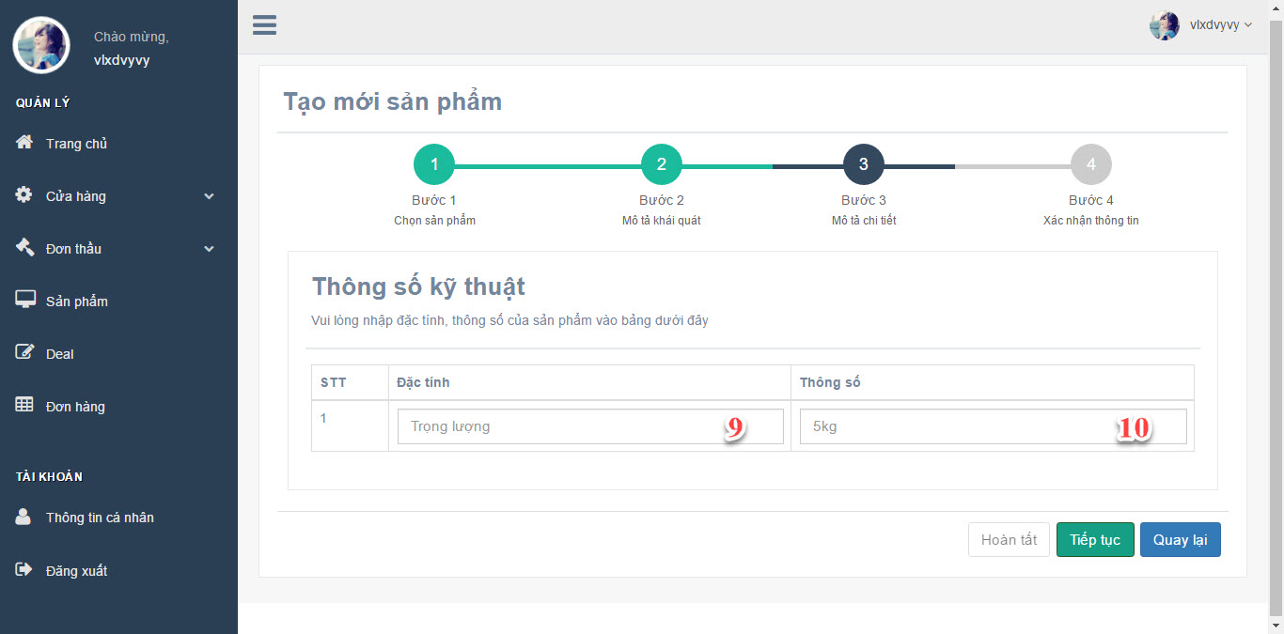**Figure 50: Add Shop’s Product (Step 3)**

**Fields**

|  |  |  |  |  |  |  |  |
| --- | --- | --- | --- | --- | --- | --- | --- |
| No | Field Name | Description | Read only | Mandatory | Control type | Data type | Length |
| 9 | Product Attribute Key | Product key | No | Yes | TextBox | String | N/A |
| 10 | Product Attribute Value | Product value | No | Yes | TextBox | String | N/A |

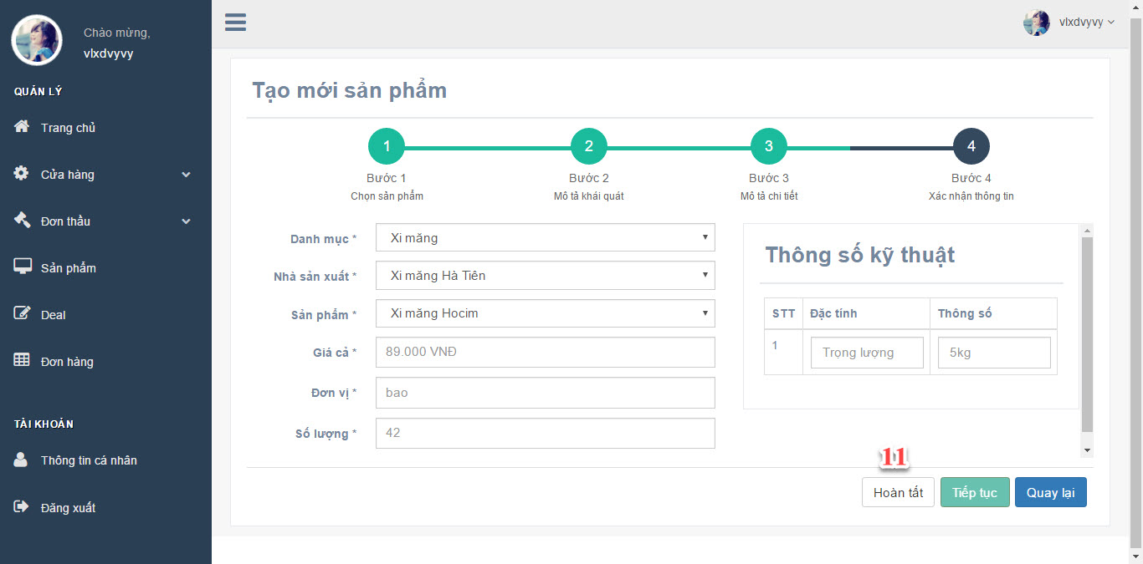

**Figure 51: Add Shop’s Product (Step 4)**

**Buttons/Hyperlinks**

|  |  |  |  |  |
| --- | --- | --- | --- | --- |
| No | Function | Description | Validation | Outcome |
| 11 | Finish | Finish add product | N/A | Redirect to Mange Product Page |

* + - 1. **Place A Bid**

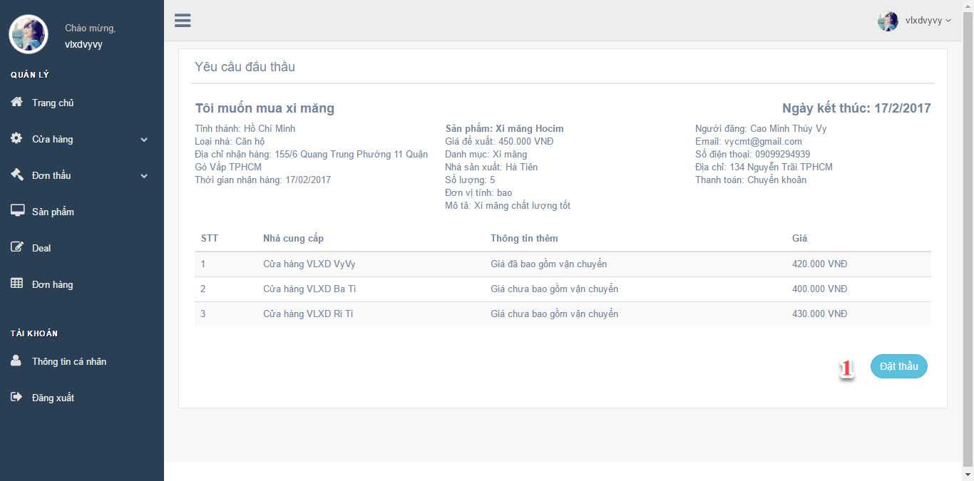

**Figure 52: Place a bid (Step 1)**

**Buttons/Hyperlinks**

|  |  |  |  |  |
| --- | --- | --- | --- | --- |
| No | Function | Description | Validation | Outcome |
| 1 | Place A Bid | Place a bid for request | N/A | Open dialog to place a bid |

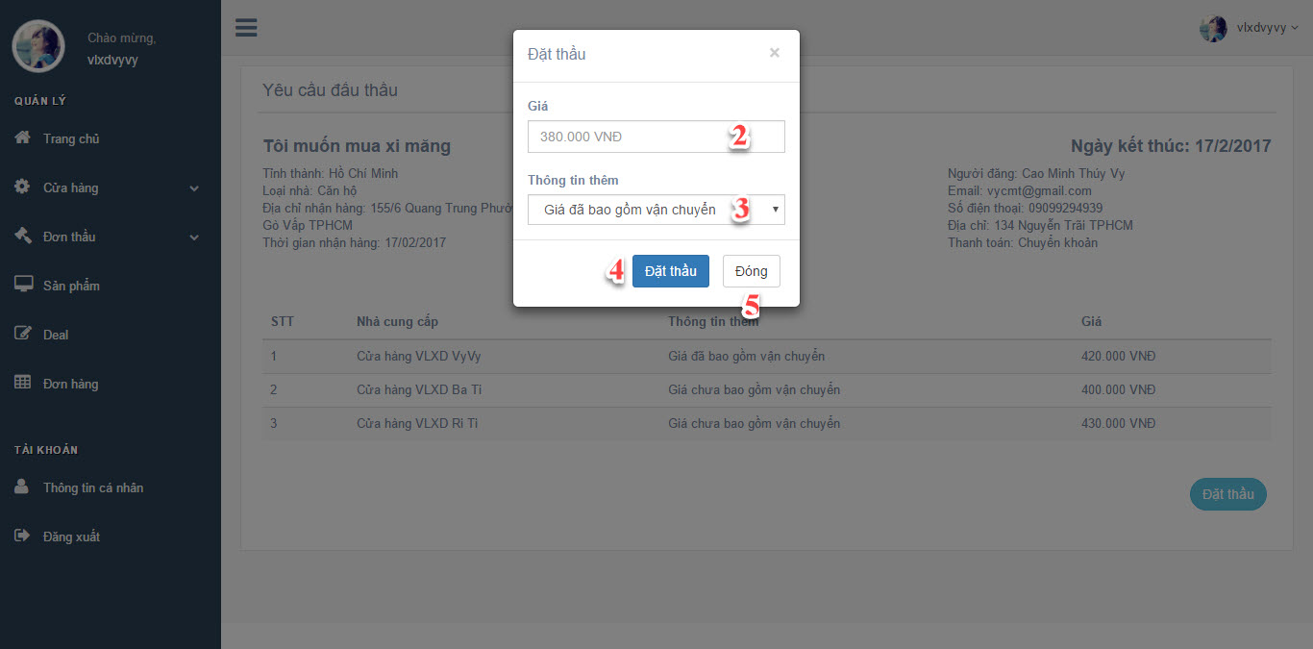

**Figure 53: Place a bid (Step 2)**

**Fields**

|  |  |  |  |  |  |  |  |
| --- | --- | --- | --- | --- | --- | --- | --- |
| No | Field Name | Description | Read only | Mandatory | Control type | Data type | Length |
| 2 | Price | Bid’s price | No | Yes | Textbox | String | N/A |
| 3 | Additional Information | Additional information | No | No | DropDownList | String | N/A |

**Buttons/Hyperlinks**

|  |  |  |  |  |
| --- | --- | --- | --- | --- |
| No | Function | Description | Validation | Outcome |
| 4 | Place A Bid | Place a bid for request | N/A | Open dialog to place a bid |
| 5 | Close | Close dialog | N/A | Close dialog |

* + 1. **Admin Interface Design**

**6. Database Design**

**6.1 Entity relationship diagram (ERD)**

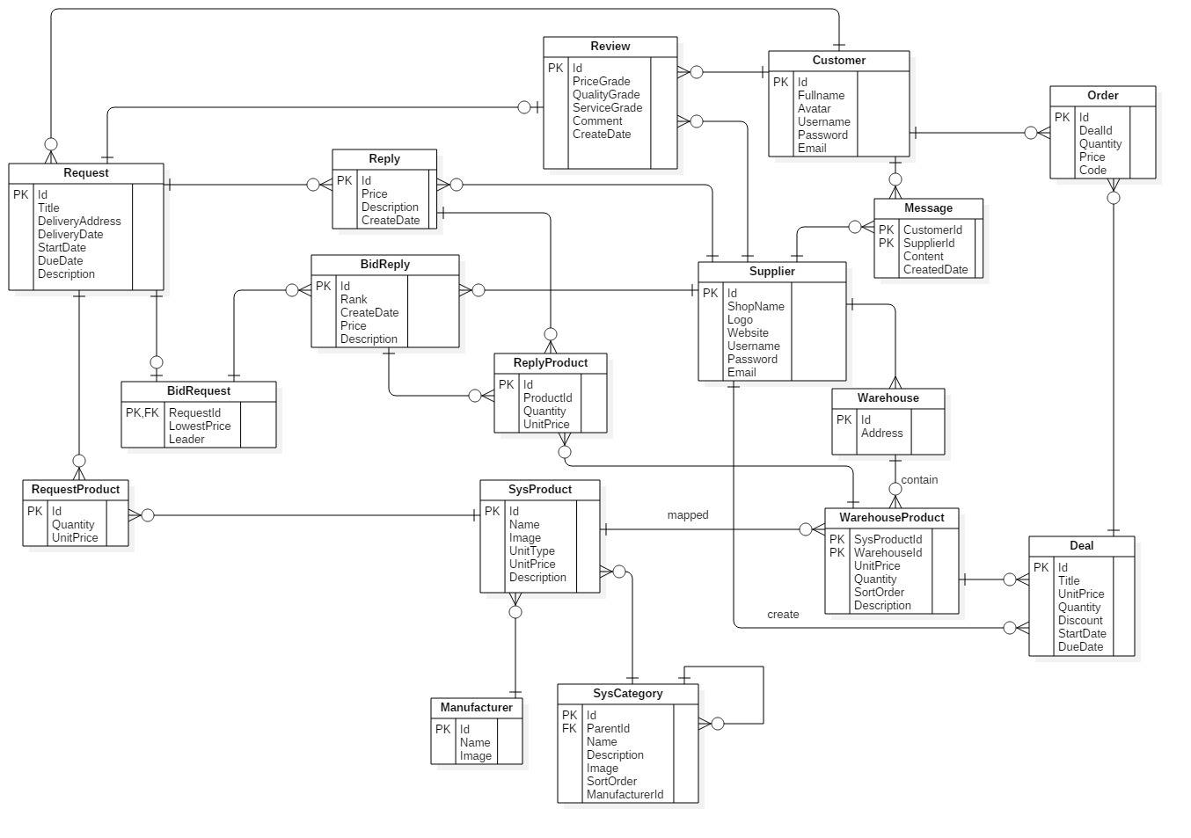

**Figure 54: Entity Relationship Diagram**

**6.2 Data Dictionary**

|  |  |
| --- | --- |
| Entity Name | Description |
| Request | Contains all info about request. |
| Request Product | Contains all info about request’s products. |
| BidRequest | Contains all info about bid’s requests. |
| BidReply | Contains all info about bid’s replies. |
| ReplyProduct | Contains all info about reply’s products. |
| SysProduct | Contains all info about system’s products. |
| SysCategory | Contains all info about system’s categories. |
| Manufacturer | Contains all info about manufacturers. |
| Review | Contains all info about reviews. |
| Customer | Contains all info about customers. |
| Supplier | Contains all info about suppliers. |
| Message | Contains all info about messages. |
| Warehouse | Contains all info about warehouses. |
| WarehouseProduct | Contains all info about warehouse’s products. |
| Order | Contains all info about orders. |
| Deal | Contains all info about deals. |

**Table 63: General Data Dictionary**

|  |  |  |  |  |
| --- | --- | --- | --- | --- |
| **Entity name** | **Attributes** | **Description** | **Domain** | **Null** |
| **Request** | Id {PK} | ID of the request | Integer | N |
| Title | Title of the request | String | N |
| DeliveryAddress | Delivery address of the request | String | Y |
| DeliveryDate | Delivery date of the request | Date | Y |
| StartDate | Start date of the request | Date | N |
| DueDate | Due date of the request | Date | N |
| Description | Description of the request | String | Y |
| **RequestProduct** | Id {PK} | ID of the request’s product | Integer | N |
| Quantity | Quantity of the request’s product | Integer | Y |
| UnitPrice | Unit price of the request’s product | Double | Y |
| **BidRequest** | RequestId {PK, FK} {}[{{}{PK,FK} | ID of the request | Integer | N |
| LowestPrice | Lowest price from supplier | Double | N |
| Leader | Supplier has lowest price | Integer | Y |
| **BidReply** | Id {PK} | ID of the bid’s reply | Integer | N |
| Rank | Rank of the bid’s reply | Integer | N |
| CreateDate | Create date of the bid’s reply | Date | Y |
| Price | Price of the bid’s reply | Double | N |
| Description | Description of the bid’s reply | String | Y |
| **ReplyProduct** | Id {PK} | ID of the reply’s product | Integer | N |
| ProductId | ID of the product | Integer | N |
| Quantity | Quantity of the reply’s product | Integer | N |
| UnitPrice | Unit price of the reply’s product | Double | N |
| **SysProduct** | Id {PK} | ID of the system’s product | Integer | N |
| Name | Name of the system’s product | String | N |
| Image | Image of the system’s product | String | Y |
| UnitType | Unit Type of the system’s product | String | N |
| **SysCategory** | Id {PK} | ID of the system’s category | Integer | N |
| ParentId {FK} | Parent ID of the system’s category | Integer | Y |
| Name | Name of the system’s category | String | N |
| Image | Image of the system’s category | String | Y |
| SortOrder | Sort order of the system’s category | Integer | Y |
| ManufacturerId | Manufacturer ID of the system’s category | Integer | Y |
| **Manufacturer** | Id {PK} | ID of the manufacturer | Integer | N |
| Name | Name of the manufacturer | String | N |
| Image | Image of the manufacturer | String | Y |
| **Review** | Id{PK} | ID of the review | Integer | N |
| PriceGrade | Price grade of the review | Integer | N |
| QualityGrade | Quality grade of the review | Integer | N |
| ServiceGrade | Service grade of the review | Integer | N |
| Comment | Comment of the review | String | Y |
| CreatedDate | Created date of the review | Date | Y |
| **Customer** | Id {PK} | ID of the customer | Integer | N |
| Fullname | Fullname of the customer | String | Y |
| Avatar | Avatar of the customer | String | Y |
| Username | Username of the customer | String | N |
| Password | Password of the customer | String | N |
| Email | Email of the customer | String | N |
| **Supplier** | Id {PK} | ID of the supplier | Integer | N |
| ShopName | Name of the supplier’s shop | String |  |
| Logo | Logo of the supplier | String |  |
| Website | Website of the supplier | String |  |
| Username | Username of the supplier | String | N |
| Password | Password of the supplier | String | N |
| Email | Email of the supplier | String | N |
| **Message** | CustomerId {PK} | Customer ID of the message | Integer |  |
| SupplierId {PK} | Supplier ID of the message | Integer |  |
| Content | Content of the message | String |  |
| CreateDate | Create Date of the message | Date |  |
| **Warehouse** | Id {PK} | ID of the warehouse | Integer | N |
| Address | Address of the warehouse | String | Y |
| **WarehouseProduct** | SysProductId {PK} | ID of the system’s product | Integer | N |
| WarehouseId {PK} | ID of the warehouse | Integer | N |
| UnitPrice | Unit price of the warehouse’s product | Double | Y |
| Quantity | Quantity of the warehouse’s product | Integer | N |
| SortOrder | Sort order of the warehouse’s product | Integer | Y |
| **Order** | Id {PK} | ID of the order | Integer | N |
| DealId | ID of the deal | Integer | N |
| Quantity | Quantity of the order | Integer | N |
| Price | Price of the order | Double | N |
| Code | Code of the order | String | N |
| **Deal** | Id {PK} | ID of the deal | Integer | N |
| Title | Title of the deal | String | N |
| UnitPrice | Unit price of the deal | Double | N |
| Quantity | Quantity of the deal | Integer | N |
| Discount | Discount of the deal | Integer | N |
| StartDate | Start date of the deal | Date | N |
| DueDate | Due date of the deal | Date | N |

**Table 64: Detail Data Dictionary**

**7. Algorithms**

*.*

\* MERGEFORMAT 1

**E. System Implementation & Test**

**1. Introduction**

**1.1 Overview**

<Mô tả tống quát mục đích test chủ yếu với thời gian và scope và số lượng nhân lực thì nhóm áp dụng phương pháp gì cho việc test>

*Ví dụ*

*This section provides in detail all necessary information about implementation information and testing procedure of MSSC includes test plans, test cases, test result and risks estimations.*

**1.2 Test Approach**

<Phương pháp kiểm thử của nhóm : black box, white box ...>

**2. Database Relationship Diagram**

**2.1 Physical Diagram**

<Vẽ database khi cài đặt vật lý trên các RDBMW: chú ý bố cục cũng nhu kích thước cho dễ đọc>

**2.2 Data Dictionary**

<Mô tả thành phần theo bảng biểu bên dưới>

|  |  |
| --- | --- |
| **Data dictionary: describe content of all tables** | |
| **Table Name** | **Description** |
| Tên | Explanation |

<Mô tả thành phần chi tiết>

|  |  |  |  |  |
| --- | --- | --- | --- | --- |
| **Entity name** | **Attributes** | **Description** | **Domain** | **Null** |
| Tên | Thuộc tính 1 {PK} | Mô tả | Kiểu dữ liệu | Y/N |
| ... | ... | ... | ... |

**Table 13: Attribute Data Dictionary**

**3. Performance Measures**

<Cách nhóm ước lượng việc đo đạc hệ thống>

*Ví dụ*

***3.1 Clustering Performance***

*Clustering is performed by running K Mean Algorithm which has complexity*

*of : O(n * k * I * d)*

o *n : number of points*

o *k : number of cluster*

o *I : number of iteration*

o *d : number of attributes (3)*

*Clustering take almost the time of process that we can ignore the time needed to load data from database, digitalize data.*

*The speed of clustering will vary and increase dramatically when n increase. The purpose of this project is not about optimizing K-Mean Algorithm so it is accepted to let the process run till it completes. Moreover, the clustering is designed to run by staff, wait time is acceptable.*

**4. Test Plan**

<Đưa ra kế hoạch test>

*Ví dụ*

*The purpose of this section is to verify and ensure that MSSC meets its design specification and other requirements from user. The following part will describe which features to be tested and which will not.*

**4.1 Features to be tested**

<Tính năng sẽ kiểm thử>

**4.2 Features not to be tested**

<Tính năng sẽ không kiểm thử>

**5. System Testing Test Case**

**<Nên vẽ các workflow tính năng sẽ test để dể hình dung, chú ý dàn trang in**

**ngang, chú ý đánh số, ngày tháng, kết quả, không sao chép>**

*Ví dụ*

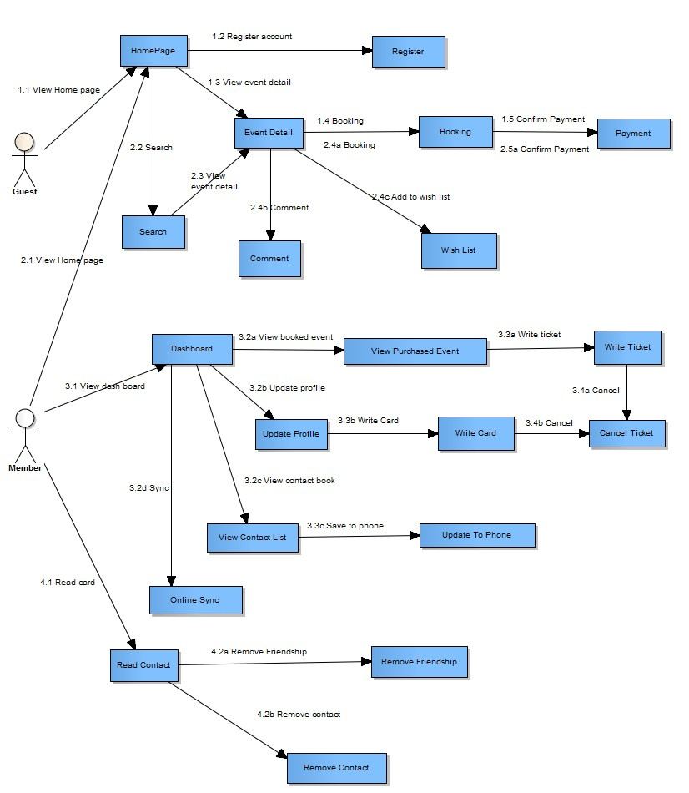

***Figure 16: Guest, Member Core Flow***

MSSC - Introduction

***5.1 Guest Test Case***

***5.1.1 Search Event***

|  |  |  |  |  |  |  |  |
| --- | --- | --- | --- | --- | --- | --- | --- |
| ***ID*** | ***Test Case***  ***Description*** | ***Test Case Procedure*** | ***Expected output*** | ***Inter-test Case***  ***Dependence*** | ***Result*** | ***Test Date*** | ***Note*** |
|  |  |  |  |  |  |  |  |

MSSC - Introduction

**F. Software User’s Manual**

**1. Installation Guide**

**1.1 Setting up environment at server side**

The following software must be installed into the server machine:

**1.1.1 Hardware requirements**

<Yêu cầu phần cứng server, chú ý xem lại các report trước để nhất quán>

**1.1.2 Software requirements**

<Yêu cầu phần mềm server, chú ý xem lại các report trước để nhất quán>

**1.2 Deployment at server side**

<Mô tả quá trình triển khai lên server thực tế, gợi ý có thể gồm các

bước sau, chú ý khi làm phải chụp hình cụ thể để hướng dẫn cũng như so sánh kết quả thành công>

**1.2.1 Prepare deployment package**

**1.2.2 Configure Server before deploy**

**1.2.3 Deploy web application on server**

**1.3 Setting up the environment at client side**

**1.3.1 Setting up for computer**

<Ghi rõ phiên bản tối thiểu để sử dụng>

**2. User Guide**

<Viết hướng dẫn sử dụng cho người dùng>

**G. Appendix**

<Các thành phần tham khảo của tài liệu chú ý tham khảo thêm cách ghi tại

47